https://medium.com/@MicroPyramid/understanding-audio-quality-bit-rate-sample-rate-14286953d71f
https://www.sweetwater.com/insync/7-things-about-sample-rate/
https://www.izotope.com/en/learn/digital-audio-basics-sample-rate-and-bit-depth.html
https://community.nxp.com/thread/380386
https://boundarydevices.com/mx6-device-tree-customization/
https://github.com/boundarydevices/linux-imx6/blob/boundary-imx_3.14.28_1.0.0_ga/arch/arm/boot/dts/imx6qdl-sabrelite.dtsi#L233
https://community.nxp.com/docs/DOC-100203
https://www.mikroe.com/audio-codec-proto-board
https://www.izotope.com/en/learn/digital-audio-basics-sample-rate-and-bit-depth.html
https://www.bbc.co.uk/bitesize/guides/z7vc7ty/revision/4
for kernel Makefile and Kconfig file
https://www.linuxjournal.com/content/kbuild-linux-kernel-build-system
https://www.linuxjournal.com/article/6568
https://www.i2c-bus.org/slave/
https://www.totalphase.com/support/articles/200349176-7-bit-8-bit-and-10-bit-I2C-Slave-Addressing
https://searchcode.com/codesearch/view/44435252/
https://pdfs.semanticscholar.org/c8b6/ca9cc74e75b1485545bebe8d770631401f5e.pdf
https://www.96boards.org/documentation/consumer/dragonboard/guides/aosp/
https://www.youtube.com/watch?v=-pehAzaP1eg
https://stackoverflow.com/questions/8485553/alsa-tutorial-required
https://www.96boards.org/documentation/consumer/dragonboard/guides/aosp/
https://renenyffenegger.ch/notes/Linux/sound/ALSA/index
http://www.volkerschatz.com/noise/alsa.html
https://www.freedesktop.org/wiki/Software/PulseAudio/Documentation/User/DefaultDevice/
https://www.freedesktop.org/wiki/Software/PulseAudio/Documentation/User/
https://www.freedesktop.org/wiki/Software/PulseAudio/Documentation/Developer/#DevelopingModules
https://www.freedesktop.org/wiki/Software/PulseAudio/
https://manpages.debian.org/testing/linux-manual-4.8/snd_soc_jack_report.9.en.html
http://www.volkerschatz.com/noise/alsa.html#intro
https://www.quora.com/Where-are-variables-stored-in-C

storage classes
http://eleceng.dit.ie/frank/IntroToC/Memory.html
https://www.guru99.com/c-storage-classes.html Important
https://www.geeksforgeeks.org/memory-layout-of-c-program/ Important
https://www.geeksforgeeks.org/audio-format/ Audio file formats
http://soundfile.sapp.org/doc/WaveFormat/
https://www.quora.com/Where-are-variables-stored-in-C
https://stackoverflow.com/questions/14588767/where-in-memory-are-my-variables-stored-in-c/14588866
https://stackoverflow.com/questions/3684760/where-are-the-local-global-static-auto-register-extern-const-volatile-var
https://www.geeksforgeeks.org/pointers-in-c-and-c-set-1-introduction-arithmetic-and-array/

Variables/automatic variables ---> stack section
- Dynamically allocated variables ---> heap section
- Initialised global variables -> data section
- Uninitialised global variables -> data section (bss)
- Static variables -> data section
- String constants -> text section/code section
- Functions -> text section/code section
- Text code -> text section/code section
- Registers -> CPU registers
- Command line inputs -> environmental/command line section
- Environmental variables -> environmental/command line section
ALSA Document:
Other web sources include a LINUX Journal article about basic ALSA programming, which includes example programs, tutorials on the ALSA project web site, which also include code fragments, and one of the developers' home page, even though it is a bit old.
To complicate matters further, many standard ALSA devices are generic and have to be followed by a colon and the card, hardware device and (optionally) subdevice separated by commas. But the hardware card and device specification can never serve as an ALSA device on their own, and indeed some ALSA devices have arguments other than these hardware-related variables.
https://www.alsa-project.org/alsa-doc/alsa-lib/pcm_plugins.html
The most important plugin is no doubt the hw plugin. It does no processing of its own, but merely accesses the hardware driver. If an application chooses a PCM parameter (sampling rate, channel count or sample format) which the hardware does not support, the hw plugin returns an error. Therefore the next most important plugin is the plug plugin which performs channel duplication, sample value conversion and resampling when necessary. Unlike the hw plugin which is used by the device hw:0,0, the device corresponding to the plug plugin is named differently, plughw:0,0. Both have as parameters the card (ID string or numerical index), device and optionally subdevice of the hardware to be accessed. (In fact, the plug device also exists, which also uses the plug plugin and has as its single argument the name of the slave (ALSA) device to send its data to. It thereby can be daisy-chained with other plugins.)
https://www.alsa-project.org/alsa-doc/alsa-lib/pcm_plugins.html

The most important plugin is no doubt the hw plugin. It does no processing of its own, but merely accesses the hardware driver. If an application chooses a PCM parameter (sampling rate, channel count or sample format) which the hardware does not support, the hw plugin returns an error. Therefore the next most important plugin is the plug plugin which performs channel duplication, sample value conversion and resampling when necessary. Unlike the hw plugin which is used by the device hw:0,0, the device corresponding to the plug plugin is named differently, plughw:0,0. Both have as parameters the card (ID string or numerical index), device and optionally subdevice of the hardware to be accessed. (In fact, the plug device also exists, which also uses the plug plugin and has as its single argument the name of the slave (ALSA) device to send its data to. It thereby can be daisy-chained with other plugins.)

For using the more complicated plugins, you will have to write your own configuration file, described in the following section. Examples for device definitions can be found below as well as in the ALSA project's documentation of its configuration file
https://www.alsa-project.org/alsa-doc/doc-php/asoundrc.php
and its lists of plugins
https://www.alsa-project.org/alsa-doc/alsa-lib/pcm_plugins.html

Configuring ALSA

Configuration files
Configuration files serve to define ALSA devices. Without these definitions, you could not use any of the features of ALSA — play no sound, adjust no mixer, nada. Still, you do not need to write a configuration file to simply play and record sound. The "built-in" configuration file alsa.conf contains definitions of devices which allow that, and much more besides . But if you have special requirements, or if you experience trouble, you might still want to add definitions of your own.
ALSA supports three tiers of configuration files. The first is alsa.conf, which is located in ALSA's data directory, usually /usr/share/alsa. This directory and its subdirectories may contain further configuration files which are sound card and plugin specific. They are included by alsa.conf depending on the sound cards present. The files in this directory are considered built-in and are not to be changed by the user or the system adminstrator.
The other two configuration files are also included by alsa.conf. The system-wide configuration is stored in /etc/asoundrc. Users can store their own configuration in the file .asoundrc in their home directory. All configuration files are parsed every time an ALSA device is opened. So changes take effect immediately, and it is not necessary to restart anything.
All configuration files share the same format, which is described in the next section.

Basic configuration file format
ALSA configuration files contain hierarchically structured parameter-value pairs. The top-level branches of the hierarchy correspond to the interfaces which ALSA offers. An interface consists of a set of ALSA API functions which allow to open a device, do whatever the interface is for, and close the device. The different interfaces have different purposes. For example, aplay and other players use the pcm interface, the program alsactl uses the ctl (control) interface, amixer uses the mixer interface, amidi the rawmidi interface and so on. (In fact most of them also use the ctl interface, at least for some features.) To create a device to be used by one of these programs, you have to define it for the corresponding interface.
The examples which I give will mostly concern the pcm interface, both because it is probably the most important and because I have almost exclusively messed around with it. (PCM stands for pulse code modulation and refers to digitised sound expressed as a stream of sample values.) Besides, the command aplay -L allows you to list all definitions in the pcm interface, which is a nice cross-check. Other interfaces are ctl (control, for controlling hardware mixers and other settings), seq (sequencer), hwdep (hardware dependent features), mixer (abstracted mixer control), and rawmidi (MIDI data I/O). The second level of the hierarchy consists of the names of ALSA devices which can be used with the particular interface in whose subtree they reside.
Let's have an example. Imagine you want to create an ALSA PCM device which accesses your first sound card and does format conversion as needed. (Ignore for now that you could do that with the device "plughw:0,0".) The plugin which handles automatic format conversion is the plug plugin. The new PCM device is created by putting the following lines into your asoundrc:

pcm.plug0 {
type plug
slave {
pcm "hw:0,0"
}
}
What this means is the following: There shall be a new device "plug0" accessible via the pcm interface. Data output on this device shall be handled by the plug plugin. The plugin uses as a slave the PCM device hw:0,0. This device definition was written in the way which is most common. However, ALSA allows some freedom in the syntax. For instance, it is allowed to put an equals sign between a parameters name and its value, and a comma or a semicolon between consecutive parameter assignments. So we could also have written:
pcm.plug0 = {
type= plug;
slave= {
pcm= "hw:0,0";
},
};
As you can see, the two compounds enclosed in curly braces are really the "values" of the parameter names preceding them, and our name for the new PCM device is a freely selectable parameter name. Even the last parameter assignment in a compound may be followed by a comma or semicolon. It should now also be clear why the slace PCM device had to be enclosed in quotes: Otherwise the comma would have been misinterpreted and led to an error message.
There are further freedoms in the syntax which we have not touched yet. It concerns compounds. The names of sub-parameters of compounds may be given either in a dot notation or in braces. The first notation was chosed above for the name of our new device, which is just a parameter in the compound pcm. The second was used for all its sub-parameters. Furthermore, the syntax of the configuration files is not line-oriented — line breaks can be inserted anywhere but are treated as white space. So the same device definition as above could also have been written in one of the two following forms:
pcm {
plug0 {
type plug slave { pcm "hw:0,0" }
}
}
or
pcm.plug0.type= plug; pcm.plug0.slave.pcm= "hw:0,0"
Now I have given you an idea of the structure of ALSA configuration files, let us have a word about the remaining basics. Parameter names seem to be made up of letters, numbers and underscores (I say this from trial and error, as it seems to be documented nowhere). Parameter values which contain characters other than letters, numbers and underscores should probably be quoted. Both parameter names and values are case sensitive. Comments in configuration files start with "#" and extend up to the end of the line. They seem to be allowed pretty much anywhere, even between a parameter's name and value.
Rather than giving the slave explicitly, we could have used a symbolic slave definition above. Then our definition of plug0 would have looked like this:
pcm_slave.slave0 {
pcm "hw:0,0"
}
pcm.plug0 {
type plug
slave slave0
}
This explicit slave definition looks pointless here, but it may have its use in some cases. One can restrict a device's hardware parameter space in the process of creating a slave, for instance to force playback on all available channels and with the maximum sampling rate. (Not that it makes any sense to force resampling by the plug plugin.) Then our slave definition would look like this:
pcm_slave.slave0 {
pcm "hw:0,0"
channels 6
rate 96000
}
If the same slave was used in multiple device definitions, one could save some typing by putting these restrictions into a separate slave definition instead of every slave compound.
Another simple feature of configuration files are aliases. They are simply a parameter assignment of an existing device name to the alias. Both are part of the same interface, and the interface name is not repeated in the value of the alias. (Please note that in some texts about the asoundrc, the word "alias" is used erroneously for any device definition.) An example with our plug0 device:
pcm.alias_plug0= plug0
(not pcm.alias_plug0= pcm.plug0) You cannot define aliases for ALSA devices with arguments .
Now we have covered the basics, you might want to read the web pages here and here as well as the file pcm_plugins.html in the ALSA library's doxygen documentation (on the web here), which provide many examples.

Troubleshooting

Useful tools
The simplest way to find out something about your sound card(s) and how ALSA sees them is calling aplay -l for playback and arecord -l for recording. These commands list the cards, hardware devices and subdevices available for playback and recording, respectively. It also lists the card ID, which can be used instead of its index to specify the card. My program alsacap, described, can do the same thing.
If you are in doubt how ALSA interprets your asoundrc (or a different one of its configuration files), you can use the command aplay -L, which prints out all the configuration of the pcm interface in a standardised form. Note that the prefix "pcm." is missing from the top-level parameter names. It is always implicit.
Another interesting option of aplay is -v, which prints out the hardware parameters of every subdevice used during playback. (Unlike the other two options mentioned, it requires a file to play.) This can for example be useful if you are using the plug plugin to play a song and want to check whether it does any resampling. My experience is that it acts smartly when the required parameters are not supported by the hardware and avoids resampling whenever possible, but you might want to check.
Why we use static keyword in your driver?
https://stackoverflow.com/questions/14423333/static-functions-in-linux-device-driver
https://community.arm.com/developer/ip-products/system/b/embedded-blog/posts/using-the-static-keyword-in-c

Linux Device Driver Dos and Don'ts
http://kernel-janitor.sourceforge.net/kernel-janitor/docs/driver-howto.html
what is probe function and its functionality?
https://docs.oracle.com/cd/E19048-01/chorus401/806-0616/devdrv-45/index.html
https://stackoverflow.com/questions/7578582/who-calls-the-probe-of-driver
https://stackoverflow.com/questions/5059501/why-is-the-probe-method-needed-in-linux-device-drivers-in-addition-to-init
How to integrate new codec on board?
https://community.nxp.com/thread/380386
https://community.nxp.com/docs/DOC-100203
Device tree:
https://git.kernel.org/pub/scm/linux/kernel/git/torvalds/linux.git/tree/Documentation/devicetree/booting-without-of.txt
https://boundarydevices.com/mx6-device-tree-customization/
https://elinux.org/Device_Tree_Usage
Sampling rate,Bit rate:
https://www.sweetwater.com/insync/7-things-about-sample-rate/
https://medium.com/@MicroPyramid/understanding-audio-quality-bit-rate-sample-rate-14286953d71f
http://www.digitizationguidelines.gov/term.php?term=samplingrateaudio
https://www.izotope.com/en/learn/digital-audio-basics-sample-rate-and-bit-depth.html
https://www.bbc.co.uk/bitesize/guides/z7vc7ty/revision/4
https://manual.audacityteam.org/man/sample_rates.html

ALSA Audio Driver Notes:
https://www.kernel.org/doc/html/latest/sound/hd-audio/notes.html
https://dri.freedesktop.org/docs/drm/sound/soc/codec.html
https://kernel.readthedocs.io/en/sphinx-samples/alsa-driver-api.html
https://wladimir-tm4pda.github.io/porting/bring_up.html
http://cs-fundamentals.com/c-programming/static-and-dynamic-linking-in-c.php
https://manpages.debian.org/testing/linux-manual-4.8/snd_soc_jack_report.9.en.html
https://renenyffenegger.ch/notes/Linux/sound/ALSA/index
http://www.volkerschatz.com/noise/alsa.html#alsacap
http://www.volkerschatz.com/noise/alsacap.html#DESCRIPTION
https://www.alsa-project.org/alsa-doc/alsa-lib/pcm_plugins.html
https://www.alsa-project.org/alsa-doc/alsa-lib/pcm_plugins.html
Jack Detection:
http://www.programmersought.com/article/9463514750/
http://www.programmersought.com/article/91081210879/
http://www.programmersought.com/article/4077704335/
http://www.programmersought.com/article/1330443777/ headset dection
http://www.programmersought.com/article/50681038303/ headset detection codeflow
http://www.programmersought.com/article/44741045766/ Audio HAL important
https://blog.csdn.net/baidu_25317683/article/details/99647351 Audio libaudiohal module analysis
https://blog.csdn.net/weixin_43013761/article/details/89471523 HAL code flow
https://blog.csdn.net/weixin_43013761/article/details/89711491?depth_1-utm_source=distribute.pc_relevant.none-task&utm_source=distribute.pc_relevant.none-task
https://blog.csdn.net/weixin_43013761/article/details/89468067
https://blog.csdn.net/weixin_42082222/article/details/85345833 Audio flinger/Audio Manager
https://blog.csdn.net/weixin_43013761/article/details/89742187?depth_1-utm_source=distribute.pc_relevant.none-task&utm_source=distribute.pc_relevant.none-task volume flow
https://download.csdn.net/download/cyhust2010/4407126?depth_1-utm_source=distribute.pc_relevant.none-task&utm_source=distribute.pc_relevant.none-task
https://blog.csdn.net/weixin_42082222/article/details/83059707?depth_1-utm_source=distribute.pc_relevant.none-task&utm_source=distribute.pc_relevant.none-task Android audio architecture analysis
https://blog.csdn.net/zhuyong006/article/details/86609943 Audio playback process (6) --- data enters AudioTrack
https://blog.csdn.net/kangear/article/details/44939429 Audio HAL
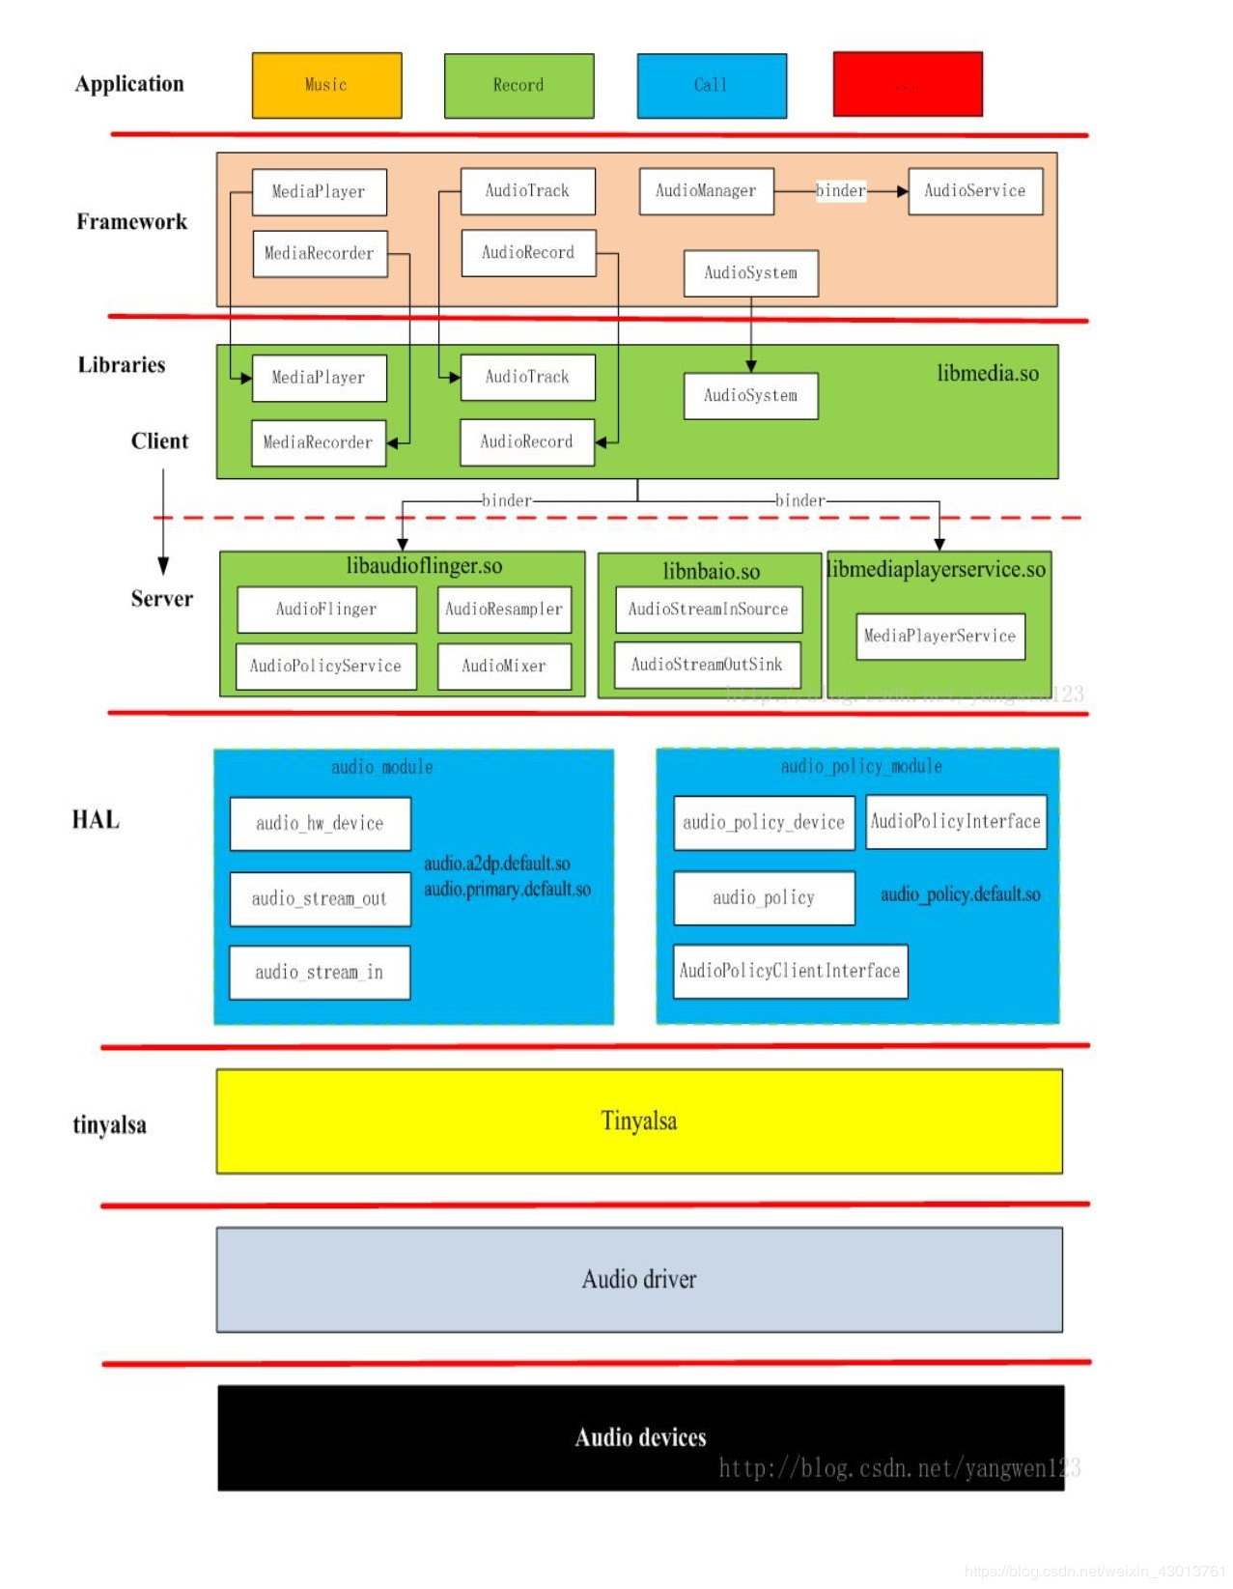
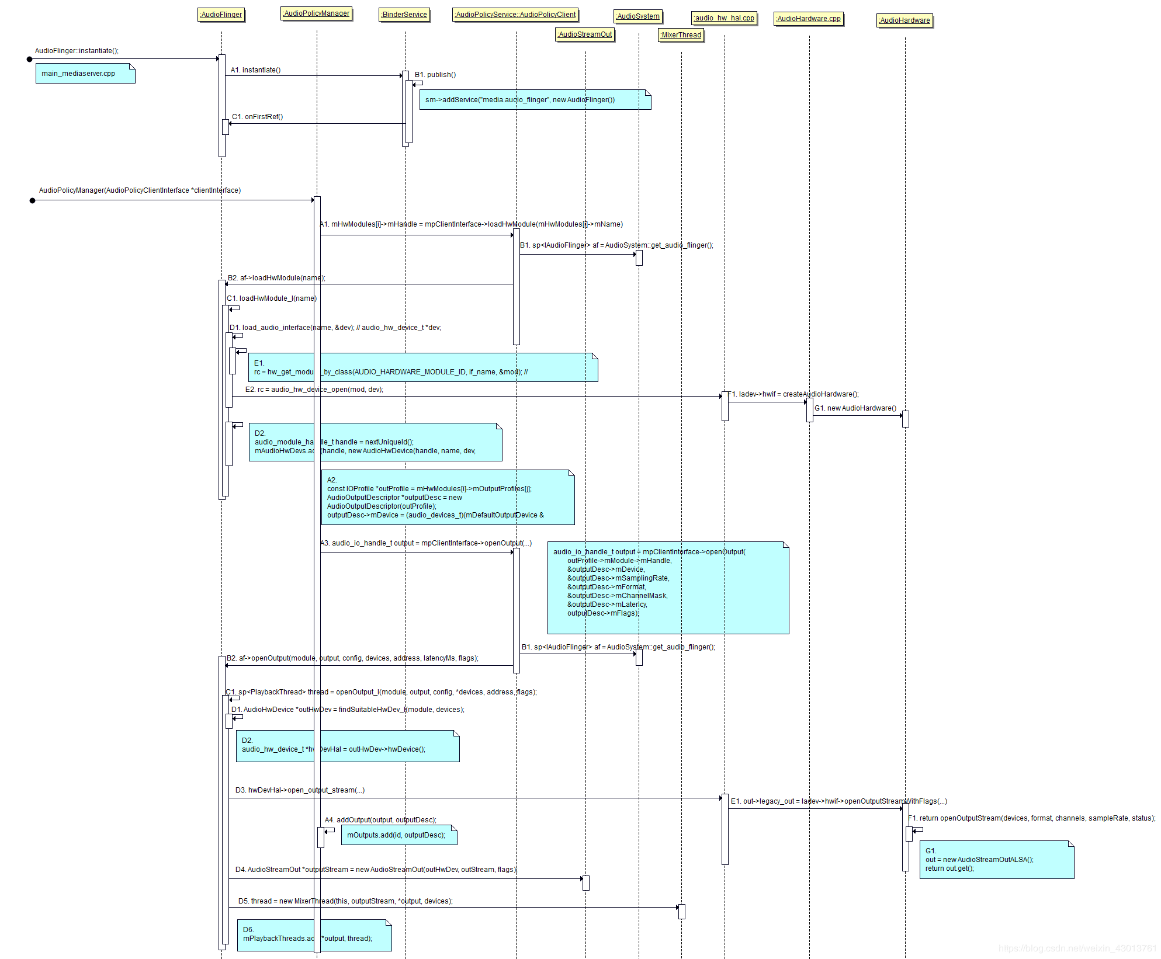

sound/soc/omap/omap-abe-twl6040.c Machine Driver
sound/soc/soc-jack.c
snd_soc_card_jack_new - Create a new jack
* @card: ASoC card
* @id: an identifying string for this jack
* @type: a bitmask of enum snd_jack_type values that can be detected by
* this jack
* @jack: structure to use for the jack
* @pins: Array of jack pins to be added to the jack or NULL
* @num_pins: Number of elements in the @pins array
* Creates a new jack object.
* Returns zero if successful, or a negative error code on failure.
* On success jack will be initialised.
int snd_soc_card_jack_new(struct snd_soc_card *card, const char *id, int type,
struct snd_soc_jack *jack, struct snd_soc_jack_pin *pins,
unsigned int num_pins)
snd_soc_jack_report - Report the current status for a jack
*
* @jack: the jack
* @status: a bitmask of enum snd_jack_type values that are currently detected.
* @mask: a bitmask of enum snd_jack_type values that being reported.
*
* If configured using snd_soc_jack_add_pins() then the associated
* DAPM pins will be enabled or disabled as appropriate and DAPM
* synchronised.
*
* Note: This function uses mutexes and should be called from a
* context which can sleep (such as a workqueue).
*/
void snd_soc_jack_report(struct snd_soc_jack *jack, int status, int mask)

OMAP3 McBSP FIFO is word structured.
* McBSP2 has 1024 + 256 = 1280 word long buffer,
* McBSP1,3,4,5 has 128 word long buffer
* This means that the size of the FIFO depends on the sample format.
* For example on McBSP3:
* 16bit samples: size is 128 * 2 = 256 bytes
* 32bit samples: size is 128 * 4 = 512 bytes
* It is simpler to place constraint for buffer and period based on
* channels.
* McBSP3 as example again (16 or 32 bit samples):
* 1 channel (mono): size is 128 frames (128 words)
* 2 channels (stereo): size is 128 / 2 = 64 frames (2 * 64 words)
* 4 channels: size is 128 / 4 = 32 frames (4 * 32 words)
Rule for the buffer size. We should not allow
* smaller buffer than the FIFO size to avoid underruns.
* This applies only for the playback stream.

https://devicetree.vger.kernel.narkive.com/dtbB23wT/patch-v2-0-4-omap-abe-twl6040-device-tree-support
https://ez.analog.com/audio/f/q-a/4259/difference-between-pdm-and-i2s-digital-microphones

I2S interface:
https://www.silvaco.com/products/IP/i2s-audio-interface/index.html?1
https://groups.google.com/forum/#!topic/beagleboard/IYL0t1yG25M
https://stackoverflow.com/questions/49587466/interfacing-an-i2s-microphone-with-beaglebone-black
https://www.ghacks.net/2017/08/16/linux-audio-explained/
http://moi.vonos.net/linux/sound-stack/

ALSA PCM:
https://www.kernel.org/doc/html/latest/sound/soc/codec.html
https://www.kernel.org/doc/html/v4.14/sound/soc/dpcm.html
http://www.programmersought.com/article/4119382422/
https://blog.csdn.net/zyuanyun/article/details/60890534 Audiotrack to Audioflinger
http://www.programmersought.com/article/9249775491/;jsessionid=F212C5D28852DF3D2D64789EB9094406
http://www.programmersought.com/article/7214349580/
http://www.programmersought.com/article/1431964078/

Linux Audio Driver: pcm and I2S interface
https://blog.csdn.net/longwang155069/article/details/53260731
https://blog.csdn.net/longwang155069/article/details/53321464#
https://blog.csdn.net/longwang155069/article/details/53392769
https://blog.csdn.net/gotowu/article/details/46329809
https://blog.csdn.net/cnclenovo/article/details/47106743

snd_soc_register_dais - Register a DAI with the ASoC core sound/soc/soc-core.c
*
* @component: The component the DAIs are registered for
* @dai_drv: DAI driver to use for the DAIs
* @count: Number of DAIs
* @legacy_dai_naming: Use the legacy naming scheme and let the DAI inherit the
* parent's name.
*/
static int snd_soc_register_dais(struct snd_soc_component *component,
struct snd_soc_dai_driver *dai_drv, size_t count)

snd_soc_register_dai - Register a DAI dynamically & create its widgets
*
* @component: The component the DAIs are registered for
* @dai_drv: DAI driver to use for the DAI
*
* Topology can use this API to register DAIs when probing a component.
* These DAIs's widgets will be freed in the card cleanup and the DAIs
* will be freed in the component cleanup.
*/
int snd_soc_register_dai(struct snd_soc_component *component,
struct snd_soc_dai_driver *dai_drv)

Let's take a look at the I2S operation of dividing the clock.

First, the master clock frequency MCLK=PCLK/ prescaler value, I2SLRCK frequency = master clock frequency /CODECLK ,

CODECLK sampling frequency type of 256fs and 384fs .

The serial is 16/32/48fs with the frequency BCLK type , which can be done by setting the serial bit number and the CODECLK sampling frequency.

Serial bit clock frequency = CODECLK adoption type / serial data bits
Android code paths:
Framework: Implement API class and service management class MediaService, AudioSystem, AudioManager. These classes are implemented using Java voice, and the code is placed under frameworks / base / media / java / android / media. Many of them are simply codes that call Libraries when they are implemented internally.
https://android.googlesource.com/platform/frameworks/base/+/refs/heads/master/media/java/android/media/ framework .java files
Libraries: Including JNI code implemented by C \ C ++, the important ones are AudioFlinger, AudioPlicyService, AudioMixer, etc. The code is in frameworks / av / media / libmedia.
https://android.googlesource.com/platform/frameworks/av/+/refs/heads/marshmallow-mr2-release/media/libmedia/ library code path .cpp files
Audio Basics:
https://en.wikipedia.org/wiki/Hearing_range
https://en.wikipedia.org/wiki/Voice_frequency
https://www.linuxjournal.com/article/6735?page=0 playback and capture flow in kernel
https://alsa.opensrc.org/ALSA
https://blog.csdn.net/jkan2001/article/details/52985329
https://blog.csdn.net/safrans/article/details/8564168
https://so.csdn.net/so/search/s.do?q=ALSA&t=blog&u=DroidPhone All ALSA Information
https://blog.csdn.net/z2066411585/article/details/99089141 difference b/w -Dhwplug:0,0 and -Dhw:0,0
https://blog.csdn.net/qq_18998145/article/details/103234944 ALSA summary
https://so.csdn.net/so/search/s.do?q=ALSA&t=blog&o=&s=&l=&f=all&viparticle= ALSA
https://blog.csdn.net/hanbo622/article/details/44703623 PLL and MCLK calculation
https://blog.csdn.net/lp542718520/article/details/70234312 playback,capture,call and voip flow
https://blog.csdn.net/xgbing/article/details/72856978 Android Audio flow
https://blog.csdn.net/sinat_37817094/article/details/80817559 aplay complete flow in ALSA
https://blog.csdn.net/a372048518/article/details/79007746 analysis of ALSA driver and AsoC
https://blog.csdn.net/reille/article/details/5845913 Porting of ALSA architecture
https://blog.csdn.net/MARTINGANG/article/details/8145615 relationship b/w alsalib and alsadriver
http://www.programmersought.com/article/88641997501/
http://www.programmersought.com/article/17131820767/
http://www.programmersought.com/article/2465118051/ ioctl
http://www.programmersought.com/article/5229833225/ How to add new codec
http://www.programmersought.com/article/7359589698/ pcm
http://www.programmersought.com/article/2847794657/
http://www.programmersought.com/article/6396800897/ overview of alsa architecture
http://www.programmersought.com/article/2420780773/ relationship b/w codec,dai and platform
http://www.programmersought.com/article/7214349580/
http://www.programmersought.com/article/9249775491/;jsessionid=F212C5D28852DF3D2D64789EB9094406 machine driver
http://www.programmersought.com/article/37511364240/ soundcard creation
http://www.programmersought.com/article/4478751727/ Asoc driver framework
http://www.programmersought.com/article/2847794657/;jsessionid=EE2FC900F0534B5BC16D95C6918C7897
http://www.programmersought.com/article/7359589698/;jsessionid=EE2FC900F0534B5BC16D95C6918C7897
https://blog.csdn.net/droidphone/article/details/6308006
http://www.programmersought.com/article/9557772336/ Asoc drive analysis
http://www.programmersought.com/article/39271443/ Asoc platform
http://www.programmersought.com/article/40061448/ Asoc codec
http://www.programmersought.com/article/9249775491/ Asoc machine
http://www.programmersought.com/article/4927541982/ alsamixer
http://www.programmersought.com/article/96302012552/ usage of alsamixer
http://www.programmersought.com/article/3507102490/ device tree
http://www.programmersought.com/article/77102059079/
http://www.programmersought.com/article/5534815175/
http://www.programmersought.com/article/4439132013/
Audacity tool:https://www.audacityflex.com/
Trace 32 Debugger:
https://so.csdn.net/so/search/s.do?q=trace32%E4%BD%BF%E7%94%A8&t=blog&o=&s=&l=&f=&viparticle=
https://blog.csdn.net/u010875635/article/details/84875567 trace32 steps
https://blog.csdn.net/aaa886868/article/details/101140906 trace32 uses
https://blog.csdn.net/zhenwenxian/article/details/6578349 trace32 on ARM dump analysis
Underrun and overrun in ALSA:
https://blog.csdn.net/Qidi_Huang/article/details/53100493
https://blog.csdn.net/qidi_huang/article/details/54020326
Jack Detection:
http://www.programmersought.com/article/4077704335/ jack detection log file

http://www.programmersought.com/article/91081210879/ jack detection

Kernel layer processing mechanism:
The Kernel layer plugs and unplugs the InputEvent processing mainly through input_report_key/input_report_switch(include/linux/input.h). In actual use, ASOC has packaged the corresponding for us. The Jack interface function can be used as long as it conforms to the specification. Here are a few common interface functions (/sound/soc/soc-jack.c).
int snd_soc_jack_new(structsnd_soc_codec *codec,
const char *id, int type, struct snd_soc_jack *jack)

Generate a new jack object, defining its type to be detected, which is the type of device that may be inserted. Generally defined as SND_JACK_HEADSET, the rest can also add SND_JACK_LINEOUT, SND_JACK_AVOUT, etc. according to the type of interface support.
This function calls snd_jack_new, and in snd_jack_new you can see that the input_allocate_device() is allocated to the input device, and the input event can be generated later.
int nd_soc_jack_add_pins(structsnd_soc_jack jack,intcount, truct snd_soc_jack_pin *pins)
Add the previously defined pins to the dapm widgets for easy dapm management. This step does not have any connection with InputEvent. It can be called. The main purpose is to define the headset socket as widgets and add dapm to save power.
Viod snd_soc_jack_report(structsnd_soc_jack *jack, int status, int mask)
Report the jack plug-in status, mainly to complete the following two tasks:
a) Update the status of the dapm pin that was previously added by snd_soc_jack_add_pins according to the plug-in status, and power-on and power-off management.
b) Call snd_jack_report, in which the input event is reported to the upper layer via input_report_key/input_report_switch.
Based on the above function, the following methods can be used to implement the headset insertion detection based on the InputEvent mechanism:
a) snd_soc_jack_new create jack object
b) snd_soc_jack_add_pins adds it to dapm wigets
c) Apply for the headset plug-in interrupt through request irq. In the interrupt handler function, determine whether the headset is plugged in or unplugged by detecting the line high level. Read the codec register to determine whether it is a headset or a headphone.
d) call snd_soc_jack_report to send an InputEvent based on the result of the judgment
In addition, ASOC provides a packaged function to implement the functions of steps c) and d) above:
int snd_soc_jack_add_gpios(struct snd_soc_jack *jack, int count,
struct snd_soc_jack_gpio *gpios)
This function requests GPIO and GPIO-related interrupts via a standard GPIO driver and provides a uniform interrupt handler to report events. This function is only available when the headset is disconnected to GPIO and the GPIO driver is a Linux standard driver, and mic detection is not supported.

platform driver:

http://www.programmersought.com/article/39271443/

In the Platform section of ASOC, it is mainly platform-dependent DMA operations and audio management. Probably the process first transfers the audio data from the memory to the dai interface on the CPU side through the DMA mode, and then through the CPU's dai interface (via the I2S bus) to the data from the Codec, the data will be decoded on the Codec side, and finally output to In the earphone/speaker.
The main functions on the platfrom side are: audio data management, audio data transmission through dma; data is passed to codec dai to codec dai, cpu has been tested.
The above two categories of functions are represented in the ASOC using two structures:
Snd_soc_dai_driver represents the dai driver on the cpu side, including the configuration of dai (audio format, clock, volume, etc.).
snd_soc_platform_driver represents the dma driver used by the platform, mainly data transmission.
Like the Machine, the snd_soc_platform structure is used to unify all platform devices.

Summary of the driver on the cpu side:
- Assign a platform driver for cpu_dai_name, register.
- Assign a struct snd_soc_dai_driver structure and set the appropriate data.
- Call the snd_soc_register_component function to register the dai structure on the cpu side.
- Assign a struct snd_soc_platform_driver structure and set the corresponding data.
- Finally call the snd_soc_add_platform function to add the snd_soc_platform_driver structure.

MFD(Multi function device):
MFD provides way to divide functionalities into core and specific function drivers. Generic functionalities(e.g. register access, generic initialisation, common functionalities, etc), can go in mfd while device specific functionalities(e.g. codec specific functionalities) can go in their specific driver.
https://rajanvaja.wordpress.com/2018/09/09/linux-multi-function-device-mfd-driver-example/

Codec driver:
https://www.kernel.org/doc/html/latest/sound/alsa-configuration.html

http://www.programmersought.com/article/40061448/

ASOC was created to make Codec independent of the CPU, reducing the coupling between the CPU and the CPU, so that the same Codec driver can be applied to any platform without modification.
It is already known in Machine that the snd_soc_dai_link structure specifies the Platform and Codec used by the Machine. On Codec side, the codec_dai and the platform side cpu_dai communicate with each other. Since they communicate with each other, they need to abide by certain rules. Codec_dai and cpu_dai are abstracted as struct snd_soc_dai structure, and dai related operations are abstracted using snd_soc_dai_driver. At the same time, all codec devices need to be abstractly encapsulated. Linux uses snd_soc_codec to abstract all codec devices, and abstracts codec drivers into snd_soc_codec_driver structure.
All in simple terms, there are four important data structures on the Codec side:
1.struct snd_soc_dai，
2.struct snd_soc_dai_driver，
3.struct snd_soc_codec，
4.struct snd_soc_codec_driver.
Summary of the codec side driver:
- Assign the platform driver with the name "codec_name", register.
- Define the struct snd_soc_codec_driver structure, set, initialize.
- Define the struct snd_soc_dai_driver structure, set, initialize.
- Register the codec by calling the snd_soc_register_codec function.
How to add codec driver?
https://github.com/conexant/codec_drivers/wiki/CX2X72x-Porting-Guide#adding-codec-driver-module-to-linux-kernel\
https://github.com/conexant/codec_drivers/wiki/CX2092X-Porting-Guide
https://git.congatec.com/android/qmx6_kernel/commit/5e8351de740d9eff26cc146a6591a4e7517496b0
https://patchwork.kernel.org/patch/4309971/
https://github.com/raspberrypi/linux/pull/3089/files
Machine Driver:
http://www.programmersought.com/article/301995625/

ASoC is divided into three parts: Machine, Platform and Codec. The Machine driver is responsible for the coupling between Platform and Codec and part and device or board specific code. Referring again to the previous section: Machine driver is responsible for processing machine-specific Some controls and audio events (for example, when playing audio, you need to open an amplifier first); separate Platform and Codec drivers do not work, it must be combined by the Machine driver to complete the audio processing of the entire device.
Everything about ASoC starts with the Machine driver, including the registration of the sound card, binding the Platform and Codec drivers, etc.
After this encapsulation, you can greatly simplify the writing of the driver. What you need to do about the Machine driver:
- Register a platform device named "soc-audio".
- Assign a struct snd_soc_card structure and set the dai_link. Set the dai_link again.
- Put the struct snd_soc_card structure into the private data of the dev of the platform device.
- Register the platform device.
Logcat command-line tool:

https://developer.android.com/studio/command-line/logcat logcat

Function Pointer:
How to declare a pointer to a function?
int myfunc(); // The function.
int (*fp)(); // Pointer to that function.
fp = myfunc; // Assigning the address of the function to the pointer.
(*fp)();
fp(); // Calling the function.
// Another way to call the function.

So then, what are function pointers ?
In simple words, a function pointer is a pointer variable which holds the address of a function and can be used to invoke that function indirectly. Function pointers are useful when you want to invoke seperate functions based on different scenarios. In that case, you just pass in the pointer to the function you want to be invoked. Function pointers are used extensively when writing code with call back scenarios.
For example, when writing code involving a XML parser, you pass in the pointers to your event handling functions and whenever there is a specific event, the XML parser calls your functions through their pointers. This function whose pointer is passed is generally called as the
call back function.

Memory Leak in c:(valgrind tool)

Memory leak occurs when programmers create a memory in heap and forget to delete it.
Question: How to deallocate dynamically allocate memory without using “free()” function.
Solution: Standard library function realloc() can be used to deallocate previously allocated memory. Below is function declaration of “realloc()” from “stdlib.h”

#include<stdio.h>
#include<stdlib.h> valgrind.c
int main()
{
int *ptr=(int*)malloc(10);
// realloc(ptr,0);
return 0;
}
Check the leak summary with valgrind tool. It shows memory leak of 10 bytes, which is highlighed in red colour.
First of all valgrind tool need to insatll in your compiler/linux machine.
gcc valgrind.c -o ajay
valgrind --leak-check=yes ./ajay

==1238== LEAK SUMMARY:
==1238== definitely lost: 10 bytes in 1 blocks.
==1238== possibly lost: 0 bytes in 0 blocks.
==1238== still reachable: 0 bytes in 0 blocks.
==1238== suppressed: 0 bytes in 0 blocks.

After deallocate memory using free(ptr) or realloc(ptr,0) the output is,
==1435== ERROR SUMMARY: 0 errors from 0 contexts (suppressed: 11 from 1)
==1435== malloc/free: in use at exit: 0 bytes in 0 blocks.
==1435== malloc/free: 1 allocs, 1 frees, 10 bytes allocated.
==1435== For counts of detected errors, rerun with: -v
==1435== All heap blocks were freed — no leaks are possible.

https://www.ibm.com/developerworks/community/blogs/6e6f6d1b-95c3-46df-8a26-b7efd8ee4b57/entry/detect_memory_leaks_with_memcheck_tool_provided_by_valgrind_part_i8?lang=en

https://www.thegeekstuff.com/2011/11/valgrind-memcheck/

Memory Layout in c:

https://www.geeksforgeeks.org/memory-layout-of-c-program/

For instance the global string defined by char s[] = “hello world” in C and a C statement like int debug=1 outside the main (i.e. global) would be stored in initialized read-write area. And a global C statement like const char* string = “hello world” makes the string literal “hello world” to be stored in initialized read-only area and the character pointer variable string in initialized read-write area.
Ex: static int i = 10 will be stored in data segment and global int i = 10 will also be stored in data segment

To see the memory occupied by each block using

#include<stdio.h>
int i=10;
int main() 1.c
{
printf(“hello”);
}
gcc 1.c -o ajay
size ajay

https://www.geeksforgeeks.org/common-memory-pointer-related-bug-in-c-programs/

Fixed point vs Floating Point Representation:

https://www.tutorialspoint.com/fixed-point-and-floating-point-number-representations

https://www.analog.com/en/education/education-library/articles/fixed-point-vs-floating-point-dsp.html#

Environmental variable in c:
https://www.geeksforgeeks.org/c-program-print-environment-variables/
https://www.quora.com/What-is-the-environment-variable-in-C-programming

Macros in c:
https://www.geeksforgeeks.org/interesting-facts-preprocessors-c/

Print a string without using quotes anywhere in the program using C or C++.
Note : should not read input from the console
A token passed to macro can be converted to a string literal by using # before it.

#include<stdio.h>
#define get(x) #x
int main()
{
printf(get(ajaykumar));
return 0;
}

Macro vs inline:

https://www.thegeekstuff.com/2013/04/c-macros-inline-functions/?utm_source=tuicool
https://www.thegeekstuff.com/2012/08/c-interview-questions/

How to check whether a program is compiled with 32-bit or 64-bit?
https://www.geeksforgeeks.org/compile-32-bit-program-64-bit-gcc-c-c/
#include<stdio.h> // size.c
int main()
{
printf("Size = %lu\n", sizeof(size_t));
}
gcc -m64 size.c -o out
./out
size=8
gcc -m32 size.c -o out
./out
size=4
Since the size of data types like long, size_t, pointer data type(int*, char* etc) is compiler dependent, therefore it will generate a different output according to bit of compiler.

Difference between gets() and fgets():
https://www.geeksforgeeks.org/fgets-gets-c-language/

Debug a c program using gdb:
https://learnlinuxconcepts.blogspot.com/2014/11/gdb.html gdb steps explanation
https://web.eecs.umich.edu/~sugih/pointers/summary.html
https://www.thegeekstuff.com/2010/03/debug-c-program-using-gdb/
http://learnlinuxconcepts.blogspot.com/2014/11/gdb.html
https://www.thegeekstuff.com/2014/01/gdb-backtrace/

c material:
https://www.emertxe.com/trainings/technical-resource-library/embedded-systems/advanced-c-programming-for-embedded-course-contents/advanced-c-programming-for-embedded-exercises-simple-programs/

Volatile:
https://www.geeksforgeeks.org/understanding-volatile-qualifier-c-set-1-introduction/
https://www.geeksforgeeks.org/understanding-volatile-qualifier-in-c/
https://barrgroup.com/Embedded-Systems/How-To/C-Volatile-Keyword

IPC Mechanisms:
pipe : unidirectional,inter process communication
https://www.geeksforgeeks.org/pipe-system-call/
https://www.geeksforgeeks.org/c-program-for-pipe-in-linux/
fork : https://www.geeksforgeeks.org/fork-system-call/

forkbomb: https://www.geeksforgeeks.org/fork-bomb/
fifo: https://www.geeksforgeeks.org/named-pipe-fifo-example-c-program/
message queue:https://www.geeksforgeeks.org/ipc-using-message-queues/
semaphore:binary semaphore,counting semaphore
https://www.geeksforgeeks.org/semaphores-in-process-synchronization/
https://www.geeksforgeeks.org/use-posix-semaphores-c/
https://www.interserver.net/tips/kb/everything-about-linux-semaphore/
Threads:
https://www.cs.cmu.edu/afs/cs/academic/class/15492-f07/www/pthreads.html#PITFALLS

mutex
spinlock

dd command in linux:
dd if = /dev/sda of = /dev/sdb
“if” represents inputfile, and “of” represents output file. So the exact copy of /dev/sda will be available in /dev/sdb.
https://www.geeksforgeeks.org/dd-command-linux/

Probe function in Drivers:
https://stackoverflow.com/questions/5059501/why-is-the-probe-method-needed-in-linux-device-drivers-in-addition-to-init

Makefile:
https://www.computerhope.com/unix/umake.htm
https://stackoverflow.com/questions/39101791/what-do-you-mean-by-make-command-in-linux
http://www.cs.colby.edu/maxwell/courses/tutorials/maketutor/
What is Makefile?
Makefile is a script written in a certain prescribed syntax which helps to build the target output (normally, one or more executables) from source files by compilation and linking. In simple words, makefile will compile your source code in simple & fast way. Why we need Makefile?
=> Large projects can contain multiple source files which are dependent in one another or arranged in hierarchical manner for example, in order to compile file A, you have to first compile B; in order to compile B, you have to first compile C; and so on.
=> Make is a solution to these problems. It can be used to compile whole project in well arranged manner and generate your target according to your make rule(which we will discuss later) by entering single command that is make.
=> An important feature is that when a project is recompiled after a few changes, it will recompile only those files which are changed, and any other files that are dependent on it. This saves a lot of time.
=> For a large project, when a few changes are made to the source, manually recompiling the entire project each time is tedious, error-prone and time-consuming.
http://www.firmcodes.com/linux/write-first-makefile-c-source-code-linux-tutorial/
https://web.stanford.edu/class/archive/cs/cs107/cs107.1174/guide_make.html

cscope:
These are very basic to understand the cscope.
- "cscope -R" Then you get options.
- Press down arrow. Then you will move to your required option. Type whatever you want at the respective option.
- From the search result. Use arrows(Up and down) then Press "enter key" to see the detailed file.
- ":q" to exit from the file.
- Press "Tab key" to come to the cscope options.
- "ctrl + d" to exit from the cscope.
Interrupts:
http://learnlinuxconcepts.blogspot.com/2014/02/interrupts.html
https://www.oreilly.com/library/view/understanding-the-linux/0596005652/ch04s06.html
https://www.kernel.org/doc/html/v4.12/core-api/genericirq.html
https://stackoverflow.com/questions/1053572/why-kernel-code-thread-executing-in-interrupt-context-cannot-sleep
https://stackoverflow.com/questions/36215399/why-interrupt-handlers-isrs-cannot-sleep
https://www.quora.com/Linux-Kernel-How-do-the-do_IRQ-function-gets-called-on-Hardware-Interrupt
https://topic.alibabacloud.com/a/the-difference-between-softirq-tasklet-and-workqueue-_softirq_8_8_20295582.html
what does the kernel when an interrupt occurres?
- The CPU checks after each instruction if there's a IRQ from the (A)PIC
- If so, consults the IDT to map the received vector to a function
- Checks if the interrupt was issued by a authorized source
- Saves the registers of the interrupted process
- Call the according function to handle the interrupt
- Load the recently saved registers of the interrupted process and try to resume it.

System call:
https://learnlinuxconcepts.blogspot.com/search?q=system+call
https://linux-kernel-labs.github.io/master/lectures/syscalls.html
system call is the programmatic way in which a computer program requests a service from the kernel of the operating system it is executed on.
At a high level system calls are “services” offered by the kernel to user applications and they resemble library APIs in that they are described as a function call with a name, parameters and return value.
Ctags:
It is a programming tool that generates index file of names found is source and header file.
- It is used in many programming languages.
- Functions, variables, class names, structures, macros are indexed, but what all names can be indexed depends on the programming language.
- Most commonly used ctags with vim editor is Exuberant Ctags.
Useful Commands
- To enable ctags in a source file give the command ctags -R *
- It parses all the names and creates a stack for each name.
- To view the definition of a function or a structure we need to take our cursor over it and enter ctrl+] command.
- To come back to fucntion call from definition we use ctrl+t.
- Following vim commands can be used to navigate through relevant functions
- :ts or :tselect shows the list
- :tn or :tnext goes to the next tag in that list
- :tp or :tprev goes to the previous tag in that list
- :tf or :tfirst goes to the first tag of the list
- :tl or :tlast goes to the last tag of the list

http://learnlinuxconcepts.blogspot.com/2014/10/how-system-call-is-executed-in-x86.html

http://learnlinuxconcepts.blogspot.com/2014/10/what-are-important-applications-of.html
http://learnlinuxconcepts.blogspot.com/2014/10/what-is-difference-between-mutex-and_14.html
http://learnlinuxconcepts.blogspot.com/2014/03/how-function-pointers-are-shared-across.html
http://learnlinuxconcepts.blogspot.com/2014/03/what-is-device-tree-in-linux.html
http://learnlinuxconcepts.blogspot.com/2014/06/passing-parameters-to-linux-device.html
https://learnlinuxconcepts.blogspot.com/2014/03/what-is-loadable-kernel-module.html Makefile and modular programming
https://learnlinuxconcepts.blogspot.com/2014/06/basics-of-linux-device-drivers.html Makefile explanation and modular programming explanation
https://www.oreilly.com/library/view/linux-device-drivers/0596005903/ch02.html modular programming and makefile
https://learnlinuxconcepts.blogspot.com/2014/07/character-device-drivers.html character driver
https://opensourceforu.com/2014/10/an-introduction-to-device-drivers-in-the-linux-kernel/
http://learnlinuxconcepts.blogspot.com/2014/07/character-device-drivers.html
The difference between struct inode and struct file is that an inode doesn't track the current
position within the file or the current mode. It only contains stuff that helps the OS find the
contents of the underlying file structure (pipe, directory, regular disk file, block/character device
file, and so on). On the other hand, the struct file is used as a generic structure (it actually holds
a pointer to a struct inode structure) that represents and open file and provides a set of functions
related to methods one can perform on the underlying file structure. Such methods are: open ,
write , seek , read , select , and so on. All this reinforces the philosophy of UNIX systems that says
everything is file.
In other words, a struct inode represents a file in the kernel, and a struct file describes it when
it is actually open. There may be different file descriptors that represent the same file opened
several times, but these will point to the same inode.
Probe vs init:
The probe function is not a substitute to init function. The probe function is called
every time when a given device matches with the driver, whereas the init
function runs only once, when the module gets loaded.
How can platform devices and platform drivers match?
So far, we have only discussed how to fill different structures of both devices and drivers.But
now we will see how they are registered with the kernel, and how Linux knows which devices
are handled by which driver. The answer is MODULE_DEVICE_TABLE . This macro lets a driver expose
its ID table, which describes which devices it can support. In the meantime, if the driver can be
compiled as a module, the driver.name field should match the module name. If it does not match,
the module won't be automatically loaded, unless we have used the MODULE_ALIAS macro to add
another name for the module. At compilation time, that information is extracted from all the
drivers in order to build a device table. When the kernel has to find the driver for a device (when
a matching needs to be performed), the device table is walked through by the kernel. If an entry
is found matching the compatible (for device tree), device/vendor id or name (for device ID table
or name) of the added device, then the module providing that match is loaded (running the
module's init function), and the probe function is called. The MODULE_DEVICE_TABLE macro is
defined in linux/module.h :
#define MODULE_DEVICE_TABLE(type, name)
The following is the description of each parameter given to this macro:
type :
This can be either i2c , spi , acpi , of , platform , usb , pci or any other bus which you may
find in include/linux/mod_devicetable.h . It depends on the bus our device sits on, or on the
matching mechanism we want to use.
name : This is a pointer on a XXX_device_id array, used for device matching. If we were
talking about I2C devices, the structure would be i2c_device_id . For SPI device, it should
[80]be spi_device_id , and so on. For the device tree Open Firmware (OF) matching
mechanism, we must use of_device_id .

Device tree:
DT is enabled in the kernel by setting the option CONFIG_OF to Y . In order to pull the DT API from
http://learnlinuxconcepts.blogspot.com/2014/02/linux-kernel-questions-and-answers.html
https://learnlinuxconcepts.blogspot.com/search?q=i2c

sound/soc/omap/omap-mcbsp.c
* OMAP3 McBSP FIFO is word structured. //Platform:omap-mcbsp,omap i2s soc interface
* McBSP2 has 1024 + 256 = 1280 word long buffer,
* McBSP1,3,4,5 has 128 word long buffer
* This means that the size of the FIFO depends on the sample format.
* For example on McBSP3:
* 16bit samples: size is 128 * 2 = 256 bytes
* 32bit samples: size is 128 * 4 = 512 bytes
* It is simpler to place constraint for buffer and period based on
* channels.
* McBSP3 as example again (16 or 32 bit samples):
* 1 channel (mono): size is 128 frames (128 words)
* 2 channels (stereo): size is 128 / 2 = 64 frames (2 * 64 words)
* 4 channels: size is 128 / 4 = 32 frames (4 * 32 words)
* Rule for the buffer size. We should not allow
* smaller buffer than the FIFO size to avoid underruns.
* This applies only for the playback stream.
* Make sure, that the period size is always even
PCM Terminology:
https://larsimmisch.github.io/pyalsaaudio/terminology.html?source=post_page-----d21d7b672305
http://soundfile.sapp.org/doc/WaveFormat/
https://larsimmisch.github.io/pyalsaaudio/terminology.html
https://stackoverflow.com/questions/24040672/the-meaning-of-period-in-alsa

Sample rate = number of samples / second
Frame = 1 sample from each channel (PCM)
Frame Size = Sample size * Channels
Frame Rate = frames / second.
For PCM the sample rate and the frame rate are the same since a frame consists of a a sample from each channel
https://www.quora.com/Linux-Kernel-How-does-copy_to_user-work
https://www.quora.com/Linux-Kernel-How-do-the-probe-function-of-Device-Driver-gets-called
https://www.quora.com/Linux-Kernel-What-are-the-commonly-encountered-issues-in-development-of-Device-Drivers
https://www.quora.com/What-are-the-common-issues-encountered-in-development-of-Linux-platform-device-drivers
preemption in kernel:
https://kernelnewbies.org/FAQ/Preemption
https://en.wikipedia.org/wiki/Kernel_preemption
void pointers:
https://www.geeksforgeeks.org/void-pointer-c-cpp/
Bitwise operators:
https://www.geeksforgeeks.org/bitwise-operators-in-c-cpp/
https://www.geeksforgeeks.org/bits-manipulation-important-tactics/
https://www.geeksforgeeks.org/what-are-the-differences-between-bitwise-and-logical-and-operators-in-cc/
1.Find the given number is a power of 2 or not ?

#include <stdio.h>
unsigned int countSetBits(int n)
{
unsigned int count = 0;
while (n) {
n &= (n - 1);
count++;
}
return count;
}
int main()
{
int i;
printf("enter a number");
scanf("%d",&i);
printf("%d\n", countSetBits(i));
return 0;
}

2.Change the bits in a particular places in a number(In hardcore)?

https://www.geeksforgeeks.org/modify-bit-given-position/

3.void pointer.

void pointer is also called as generic pointer.A void pointer is a pointer that has no associated data type with it. A void pointer can hold address of any type and can be typcasted to any type.
int a = 10;
char b = 'x';

void *p = &a; // void pointer holds address of int 'a'
p = &b; // void pointer holds address of char 'b'

#include<stdio.h>
int main()
{
int a[2] = {1, 2};
void *ptr = &a; //doubt
ptr = ptr + sizeof(int);
printf("%d", *(int *)ptr);
return 0;
}
o/p is 2.
It has some limitations −

1) Pointer arithmetic is not possible with void pointer due to its concrete size.

2) It can’t be used as dereferenced.

4.About static keyword.

https://www.geeksforgeeks.org/static-variables-in-c/
https://www.geeksforgeeks.org/what-are-static-functions-in-c/
https://stackoverflow.com/questions/572547/what-does-static-mean-in-c
https://stackoverflow.com/questions/14588767/where-in-memory-are-my-variables-stored-in-c/14588866
https://en.wikipedia.org/wiki/Segmentation_fault
Initialized static variables are stored in the data segment of the C program whereas uninitialized ones are stored in the BSS segment.

Another information about static: If a variable is global and static, it has the life time of the C program, but it has file scope. It is visible only in that file.
There are 2 cases:

(1) Local variables declared static: Allocated in data segment instead of stack. Its value retains when you call the function again.

(2) Global variables or functions declared static: Invisible outside compilation unit (i.e. are local symbols in symbol table during linking)
Android boot sequence:
http://learnlinuxconcepts.blogspot.com/2014/02/android-boot-sequence.html
process Management:
http://learnlinuxconcepts.blogspot.com/2014/03/process-management.html
basics of kernel:
http://learnlinuxconcepts.blogspot.com/2014/03/explain-basics-of-linux-kernel.html

process vs thread:
https://www.geeksforgeeks.org/difference-between-process-and-thread/
https://stackoverflow.com/questions/200469/what-is-the-difference-between-a-process-and-a-thread
Android build steps for dragon board410c:
https://www.96boards.org/documentation/consumer/dragonboard/guides/aosp/
https://source.android.com/setup/build/building-kernels
How to find the platform and machine drivers in your code?
By seeing the Kconfig and Makefile in our code.we can decide the platform and machine drivers.
Suppose we have intel platform then go to sound/soc/intel/Kconfig and Makefile and for qualcomm chipsets go to sound/soc/qcom/Kconfig and Makefile.

config SND_OMAP_SOC_OMAP_ABE_TWL6040
tristate "SoC Audio support for OMAP boards using ABE and twl6040 codec"
depends on TWL6040_CORE && SND_SDMA_SOC && COMMON_CLK
depends on ARCH_OMAP4 || (SOC_OMAP5 && MFD_PALMAS) || COMPILE_TEST
select SND_OMAP_SOC_DMIC
select SND_OMAP_SOC_MCPDM
select SND_SOC_TWL6040
select SND_SOC_DMIC
select COMMON_CLK_PALMAS if (SOC_OMAP5 && MFD_PALMAS)
select CLK_TWL6040
help
Say Y if you want to add support for SoC audio on OMAP boards using
ABE and twl6040 codec. This driver currently supports:
- SDP4430/Blaze boards
- PandaBoard (4430)
- PandaBoardES (4460)
- omap5-uevm (5432)
sizeof() operator:
It is a compile time unary operator which can be used to compute the size of its operand. The result of sizeof is of unsigned integral type which is usually denoted by size_t.
https://www.geeksforgeeks.org/sizeof-operator-c/
https://www.geeksforgeeks.org/is-sizeof-for-a-struct-equal-to-the-sum-of-sizeof-of-each-member/
https://www.geeksforgeeks.org/using-sizof-operator-with-array-paratmeters/
https://www.geeksforgeeks.org/implement-your-own-sizeof/
https://www.geeksforgeeks.org/whats-difference-between-array-and-array-for-int-array5/
https://www.geeksforgeeks.org/write-header-file-c/
https://www.geeksforgeeks.org/print-hello-world-c-without-using-header-file/
https://www.geeksforgeeks.org/difference-between-pointer-to-an-array-and-array-of-pointers/
Adavantages of pointers:
https://www.quora.com/What-are-the-advantages-of-a-pointer-in-the-C-programming-language
Advantages:
- simulating call by reference.
- Returning more than one value.
- Accessing dynamically allocated memory.
- Implementing data structures like linked lists,trees and graphs.
- Improving efficiency.
How to modify a const variable in c?
https://www.geeksforgeeks.org/how-to-modify-a-const-variable-in-c/
https://www.geeksforgeeks.org/difference-between-const-int-const-int-const-and-int-const/
https://www.geeksforgeeks.org/difference-const-char-p-char-const-p-const-char-const-p/

I2C protocol:
https://www.totalphase.com/support/articles/200349156-I2C-Background
https://www.totalphase.com/support/articles/200349166-I2C-Glossary
https://aticleworld.com/i2c-bus-protocol-and-interface/
http://www.esacademy.com/en/library/technical-articles-and-documents/miscellaneous/i2c-bus.html
https://aticleworld.com/difference-between-i2c-and-spi/

sound/soc/twl4030.c
UART:
http://www.circuitbasics.com/basics-uart-communication/
https://www.codrey.com/embedded-systems/uart-serial-communication-rs232/
TRACE32:
https://www.lauterbach.com/frames.html?tut_optimized.html
pandaboard:
https://www.mouser.in/new/pandaboardorg/pandaboard/
bitbake and poky:
https://stackoverflow.com/questions/35853038/what-is-bitbake-and-poky
pops and clicks:
https://www.maximintegrated.com/en/glossary/definitions.mvp/term/pop-noise/gpk/886
https://www.audio-technica.com/cms/resource_library/files/f1784be31d25101f/audacity_removing_noise_and_clicks.pdf
https://www.loopmasters.com/articles/2430-Ways-To-Avoid-Pops-Clicks-In-Your-Audio-Recordings Important
It is recommended to use the following sequence for achieving optimal pop performance at power-up:
1. Choose the value of Rpop, N (time constants) and soft-stepping step time for slow power-up.
2. Choose the configuration for output drivers, including common modes and output stage power connections
3. Select the signals to be routed to headphones.
4. Power-up the blocks driving signals into HPL and HPR, but keep it muted
5. Unmute HPL and HPR and set the desired gain setting.
6. Power-on the HPL and HPR drivers.
7. Unmute the block driving signals to HPL and HPR after the Driver PGA flags are set to indicate completion of soft-stepping after power-up. These flags can be read from B0_P1_R63_D[7:6].

Headset Detection:
https://www.headphonesty.com/2019/04/headphone-jacks-plugs-explained/
This feature is enabled by programming B0_P0_R67_D7. In order to avoid false detections due to
mechanical vibrations in headset jacks or microphone buttons, a debounce function is provided for glitch rejection. For the case of headset insertion/removal, a debounce function with a range of 16ms - 512ms is provided. This can be programmed via B0_P0_R67_D[4:2]. For improved button-press detection, the debounce function has a range of 8ms to 32ms by programming B0_P0_R67_D[1:0].
The TLV320AIC3262 also provides feedback to user when a button press, or a headset insertion/removal event is detected through register readable flags as well as an interrupt on the IO pins. The value in B0_P0_R46_D[5:4] provides the instantaneous state of button press and headset insertion. B0_P0_R44_D5 is a sticky (latched) flag that is set when the button-press event is detected.B0_P0_R44_D4 is a sticky flag that is set when the headset insertion or removal event is detected. These sticky flags are set by the event occurrence, and are reset only when read. This requires polling B0_P0_R44. To avoid polling and the associated overhead, the TLV320AIC3262 also provides an interrupt feature where the events can trigger the INT1 and/or INT2 interrupts. These interrupt events can be routed to one of the digital output pins. Please see Section 2.13.4 for details on interrupts (INT1 and INT2) and Section 2.13.4 for details on digital pin routing.
As shown in Figure 2-93 and Figure 2-94, the TLV320AIC3262 not only detects a headset insertion event, but also distinguishes between the different headsets inserted, such as stereo headphones, stereo cellular headsets with microphone, mono headsets with microphone, and mono headset without microphone. After the headset-detection event, the user can read B0_P0_R37_D[5:4] and B0_P0_R37_D[1:0] to determine the type of headset inserted.

Bugs:
ASoC: no backend DAIs enabled for Audio Port
https://bugzilla.redhat.com/show_bug.cgi?id=1611529
https://forums.fedoraforum.org/showthread.php?318951-No-sound-in-linx7-tablet-intel-sst-audio-bug
https://bugzilla.kernel.org/show_bug.cgi?id=115201#c14
https://bugs.launchpad.net/zorin-os/+bug/1815907
https://bugzilla.kernel.org/show_bug.cgi?id=195811
https://e2e.ti.com/support/legacy_forums/omap/f/885/t/296063
https://litets.com/article/2019/4/9/300.html

Deep checking the jack-detect:
$ cat /proc/cmdline
BOOT_IMAGE=/boot/vmlinuz-4.18.0-0.rc6.git0.1.fc29.x86_64 root=UUID=9cf362ab-27de-43aa-b896-889b33189994 ro rhgb quiet snd_soc_sst_bytcr_rt5640.quirk=0x563423
- Does not work properly. But I noticed that after I connect the headset the output connector automatically changes to "mono speaker".
And after I disconnect the headset the output connector automatically changes to "headphones".
The action is "inverted". It is weird.
Command for sound cards:pacmd list-cards
https://bbs.archlinux.org/viewtopic.php?id=207085
https://www.quora.com/q/programmersworld?__filter__=all&__ni__=0&__nsrc__=1&__sncid__=3626441815&__snid3__=5948632699&__tiid__=4693840&sort=top#anchor
virtual memory:
tutorialspoint.com/operating_system/os_virtual_memory.htm
https://www.studytonight.com/operating-system/virtual-memory
Linux performance Analysis:
https://www.tecmint.com/command-line-tools-to-monitor-linux-performance/
https://www.tecmint.com/linux-performance-monitoring-tools/
http://www.brendangregg.com/linuxperf.html
https://www.tecmint.com/command-line-tools-to-monitor-linux-performance/
Linux memory Analysis:
https://www.cyberciti.biz/programming/linux-memory-forensics-analysis-tools/
http://www.admin-magazine.com/Articles/Forensic-Analysis-on-Linux
https://countuponsecurity.com/2019/10/14/notes-on-linux-memory-analysis-lime-volatility-and-lkms/
Understanding memory information on Linux systems:
https://linux-audit.com/understanding-memory-information-on-linux-systems/
https://www.networkworld.com/article/2722141/making-sense-of-memory-usage-on-linux.html
https://www.cyberciti.biz/faq/how-to-check-running-process-in-ubuntu-linux-using-command-line/
https://www.networkworld.com/article/3394603/when-to-be-concerned-about-memory-levels-on-linux.html
https://www.linuxjournal.com/article/2770
https://phoenixnap.com/kb/check-cpu-usage-load-linux
https://geekflare.com/process-cpu-memory-monitoring/
emertxe material:
https://www.emertxe.com/trainings/technical-resource-library/
https://emertxe.com/blog/2017/09/bitwise-operators-in-c.html
https://emertxe.com/blog/2017/10/linux-internals-interview-questions-multitasking-memory-management-ipc-mechanisms.html
https://emertxe.com/blog/2018/01/difference-between-typedef-and-macro-in-c.html
https://emertxe.com/blog/2017/09/c-programming-common-pointer-mistakes.html
https://emertxe.com/blog/?s=c+
https://emertxe.com/blog/2018/02/enumeration-in-c.html
https://emertxe.com/blog/2017/10/linux-internals-interview-questions-multitasking-memory-management-ipc-mechanisms.html
https://emertxe.com/blog/2017/10/android-things-an-introduction-to-build-embedded-devices.html
https://emertxe.com/blog/2014/11/volatile-demistyfied.html
https://emertxe.com/blog/2014/05/pointer-constant-constant-pointer-differences-2.html
https://emertxe.com/blog/2014/05/void-pointers-its-genericness.html
https://emertxe.com/blog/2014/04/pit-falls-of-bit-fields-2.html
https://emertxe.com/blog/2014/03/face-off-with-sizeof.html
https://emertxe.com/blog/2014/03/dangling-pointers-be-strictly-avoided-2.html
https://emertxe.com/blog/2014/02/stack-overflow-interrupts-your-flow-2.html
https://emertxe.com/blog/2014/02/bit-fields-be-bit-careful-while-using.html

Audio flinger:
http://gopinaths.gitlab.io/post/android-audio-framework-architecture/
http://strayinsights.blogspot.com/2018/05/android-audio-tutorial-part-one.html
http://strayinsights.blogspot.com/2018/07/android-treble-architecture-part-2.html
http://strayinsights.blogspot.com/2018/05/android-audio-tutorial-part-three.html
http://strayinsights.blogspot.com/2018/05/android-audio-tutorial-part-four.html
http://strayinsights.blogspot.com/2018/05/android-audio-tutorial-part-five.html
http://strayinsights.blogspot.com/2018/05/android-audio-tutorial-part-six.html
http://strayinsights.blogspot.com/2018/04/android-binder-tutorial_25.html

Audio stragefright player:
https://quandarypeak.com/2013/08/androids-stagefright-media-player-architecture/
http://gopinaths.gitlab.io/post/audio_codec_in_linux/
https://www.appknox.com/blog/stagefright-everything-you-need-to-know-about-this-android-megabug

Interleaved and Non interleaved:
https://stackoverflow.com/questions/17879933/whats-the-interleaved-audio
Interleaved vs Non Interleaved:https://stackoverflow.com/questions/17879933/whats-the-interleaved-audio
Audio guy here. There are two general types of stereo audio files that can be created from a music production/editing system: interleaved, and, non-interleaved. These terms refer exclusively to stereo audio files.In an interleaved file, you have a single file containing both L and R sides of a stereo recording. A non-interleaved file is always two files, one for L, the other for R. It's almost always referred to as a non-interleaved file even though there are two separate files for that piece of audio.
Generally speaking, if you have 2 channels, let's call them L for left and R for right, and you want to transmit or store 20 samples, then:
Interleaved = LRLRLRLRLRLRLRLRLRLR
Non-Interleaved = LLLLLLLLLLRRRRRRRRR
good answer, although non-interleaved generally means that you would actually have two buffers for your example, one containing only left samples, and one containing only right samples
ALSA:
https://vovkos.github.io/doxyrest/samples/alsa/page_pcm.html
http://www.qnx.com/developers/docs/6.5.0SP1.update/com.qnx.doc.neutrino_audio/libs/snd_pcm_write.html
https://alsa.opensrc.org/HowTo_Asynchronous_Playback
https://www.mjmwired.net/kernel/Documentation/sound/alsa/ALSA-Configuration.txt
AsoC:
https://www.mjmwired.net/kernel/Documentation/sound/alsa/ALSA-Configuration.txt
https://www.alsa-project.org/wiki/ASoC
https://www.alsa-project.org/wiki/DAPM
https://www.alsa-project.org/wiki/Firmware
aplay:
https://alsa.opensrc.org/HowTo_Asynchronous_Playback
http://epic-alfa.kavli.tudelft.nl/share/doc/alsa-lib-devel-1.0.22/doxygen/html/pcm.html
https://stackoverflow.com/questions/27791694/alsa-application-to-read-and-play-a-wav-file-on-raspberry-pi
https://gist.github.com/ghedo/963382
https://fossies.org/linux/alsa-utils/aplay/aplay.c
https://www.instructables.com/id/Test-Sound-Card-and-Speakers-in-Raspberry-Pi/
https://www.techonthenet.com/c_language/directives/ifdef.php
https://stackoverflow.com/questions/3744608/the-role-of-ifdef-and-ifndef
https://linux.die.net/man/3/le16toh
http://jedi.ks.uiuc.edu/~johns/links/music/audiofile1.html
https://linux.die.net/man/3/getopt_long
https://en.wikibooks.org/wiki/C_Programming/string.h/strstr
https://linux.die.net/man/3/strcasecmp
http://www.qnx.com/developers/docs/6.5.0SP1.update/com.qnx.doc.neutrino_audio/libs/snd_pcm_open.html
playback API’s used when aplay:
https://www.alsa-project.org/alsa-doc/alsa-lib/group___p_c_m.html#ga8d9ed4a62c17402de0389fd31fc7dc1f
http://www.qnx.com/developers/docs/6.5.0SP1.update/com.qnx.doc.neutrino_audio/pcm.html#OpeningYourPCMDevice
http://www.mikecramer.com/qnx/qnx_6.1_docs/neutrino/audio/libs/snd_pcm_open.html
https://gist.github.com/ghedo/963382/815c98d1ba0eda1b486eb9d80d9a91a81d995283
http://equalarea.com/paul/alsa-audio.html
https://stackoverflow.com/questions/14398573/alsa-api-how-to-play-two-wave-files-simultaneously
http://0pointer.de/blog/projects/guide-to-sound-apis.html
https://alsa-devel.alsa-project.narkive.com/bIIuylIr/scope-of-snd-pcm-hw-params-alloca
static:
https://www.geeksforgeeks.org/initialization-global-static-variables-c/
https://codeforwin.org/2017/09/static-variables-c.html
https://www.quora.com/What-is-difference-between-local-static-and-global-static-variables
http://www.mathcs.emory.edu/~cheung/Courses/255/Syllabus/1-C-intro/scope-global.html
https://vovkos.github.io/doxyrest/samples/alsa/page_pcm.html
Handshake between application and library
getopt() function:
https://www.suchprogramming.com/command-line-c/
https://stackoverflow.com/questions/3939157/c-getopt-multiple-value
https://pubs.opengroup.org/onlinepubs/009695399/functions/getopt.html
https://www.theurbanpenguin.com/using-getopt-parse-arguments-c/
https://www.gnu.org/software/libc/manual/html_node/Using-Getopt.html
https://stackoverflow.com/questions/28139701/c-programming-with-getopt-giving-command-line-flags-criteria
https://stackoverflow.com/questions/19604413/getopt-optional-arguments
http://man7.org/linux/man-pages/man3/getopt.3.html
https://www.cs.rutgers.edu/~pxk/416/notes/c-tutorials/getopt.html
int getopt_long(int argc, char * const argv[],
const char *optstring,
const struct option *longopts, int *longindex);
getopt_long[]:
https://stackoverflow.com/questions/39966025/understanding-option-long-options-when-using-getopt-long
https://stackoverflow.com/questions/27998009/how-to-correctly-close-and-free-alsa-resources
https://alsa-devel.alsa-project.narkive.com/ACV7nsKv/alsa-lib-0002124-snd-config-update-free-global-kills-applications-using-user-space-alsa-plugins
http://crasseux.com/books/ctutorial/argc-and-argv.html
https://alsa-devel.alsa-project.narkive.com/QoIDGdpD/snd-pcm-info-alloca-ptr-allocate-an-invalid-snd-pcm-info-t
https://www.alsa-project.org/alsa-doc/alsa-lib/group___output.html#gaca78d01bf6d081274650794861373c7d
https://www.gnu.org/software/gettext/manual/html_node/lib_002fgettext_002eh.html
The ALSA PCM API uses a different behaviour when the device is opened with blocked or non-blocked mode. The mode can be specified with mode argument in snd_pcm_open() function. The blocked mode is the default (without SND_PCM_NONBLOCK mode). In this mode, the behaviour is that if the resources have already used with another application, then it blocks the caller, until resources are free. The non-blocked behaviour (with SND_PCM_NONBLOCK) doesn't block the caller in any way and returns -EBUSY error when the resources are not available. Note that the mode also determines the behaviour of standard I/O calls, returning -EAGAIN when non-blocked mode is used and the ring buffer is full (playback) or empty (capture). The operation mode for I/O calls can be changed later with the snd_pcm_nonblock() function
https://alsa-devel.alsa-project.narkive.com/aQls93K1/snd-pcm-writei-vs-snd-pcm-mmap-writei
http://kom.aau.dk/group/05gr506/report/node21.html
https://www.alsa-project.org/alsa-doc/alsa-lib/pcm.html
ALSA knows about five access modes. The first three can be used for direct communication. The access mode SND_PCM_ACCESS_MMAP_INTERLEAVED determines the direct memory area and interleaved sample organization. Interleaved organization means, that samples from channels are mixed together. The access mode SND_PCM_ACCESS_MMAP_NONINTERLEAVED determines the direct memory area and non-interleaved sample organization. Each channel has a separate buffer in the case. The complex direct memory organization represents the SND_PCM_ACCESS_MMAP_COMPLEX access mode. The sample organization does not fit the interleaved or non-interleaved access modes in the case. The last two access modes describes the read / write access methods. The SND_PCM_ACCESS_RW_INTERLEAVED access represents the read / write interleaved access and the SND_PCM_ACCESS_RW_NONINTERLEAVED represents the non-interleaved access
https://stackoverflow.com/questions/6168636/how-to-trigger-sigusr1-and-sigusr2
The SIGUSR1 and SIGUSR2 signals are set aside for you to use any way you want. They’re useful for simple interprocess communication, if you write a signal handler for them in the program that receives the signal.The default action is to terminate the process.
https://patchwork.kernel.org/patch/9819731/

ALSA Documentation:
https://www.mjmwired.net/kernel/Documentation/sound/alsa/soc/overview.txt
https://www.mjmwired.net/kernel/Documentation/sound/alsa/ALSA-Configuration.txt
https://stackoverflow.com/questions/4299669/what-does-printf-hello-world-n-mean
http://www.qnx.com/developers/docs/6.5.0/index.jsp?topic=%2Fcom.qnx.doc.neutrino_audio%2Farchitecture.html&cp=13_1_1_0&anchor=QSA
http://www.qnx.com/developers/docs/6.5.0/index.jsp?topic=%2Fcom.qnx.doc.neutrino_audio%2Flibs%2Fsnd_ctl_open.html
http://paulbourke.net/dataformats/audio/
https://stackoverflow.com/questions/57212619/better-than-safe-read-and-read
https://stackoverflow.com/questions/15846741/alsa-default-vs-hw0-0
https://superuser.com/questions/53957/what-do-alsa-devices-like-hw0-0-mean-how-do-i-figure-out-which-to-use
https://stackoverflow.com/questions/3957025/what-does-a-audio-frame-contain
https://www.geeksforgeeks.org/getopt-function-in-c-to-parse-command-line-arguments/
https://en.wikipedia.org/wiki/Audio_file_format
hw:0,0 specifies the default device, on the default sound card. To access your second soundcard's first device, you would specify hw:1,0. These are specified in your .asoundrc.
SIGABRT: The abort signal is normally sent by a program when it wants to terminate itself and leave a core dump around.
SIGTERM:This signal is sent when the user wants a program to terminate gracefully.
Android Audio:
https://developer.android.com/guide/topics/media
https://blog.mindorks.com/using-mediaplayer-to-play-an-audio-file-in-android
https://www.sitepoint.com/a-step-by-step-guide-to-building-an-android-audio-player-app/
Frequently asked questions in ALSA:
http://web.mit.edu/linux/redhat/redhat-4.0.0/i386/doc/HTML/ldp/Sound-HOWTO-6.html
ALSA Doc:
https://www.kernel.org/doc/html/v4.10/sound/kernel-api/writing-an-alsa-driver.html#pcm-interface
http://www.microsofttranslator.com:81/bv.aspx?from=&to=en&rr=HE&a=http%3a%2f%2fblog.csdn.net%2fzyuanyun%2farticle%2fdetails%2f59180272%23t6
TinyALSA:
https://github.com/tinyalsa/tinyalsa/blob/master/README.md
https://github.com/tinyalsa/tinyalsa/issues/81
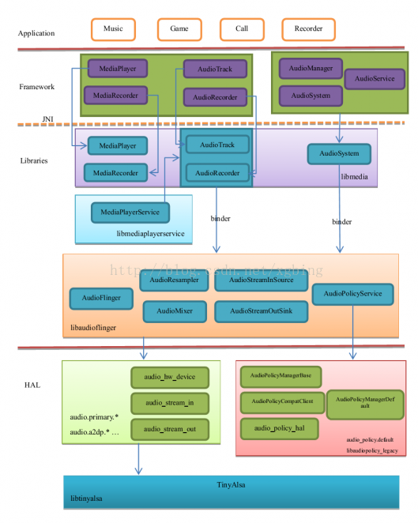

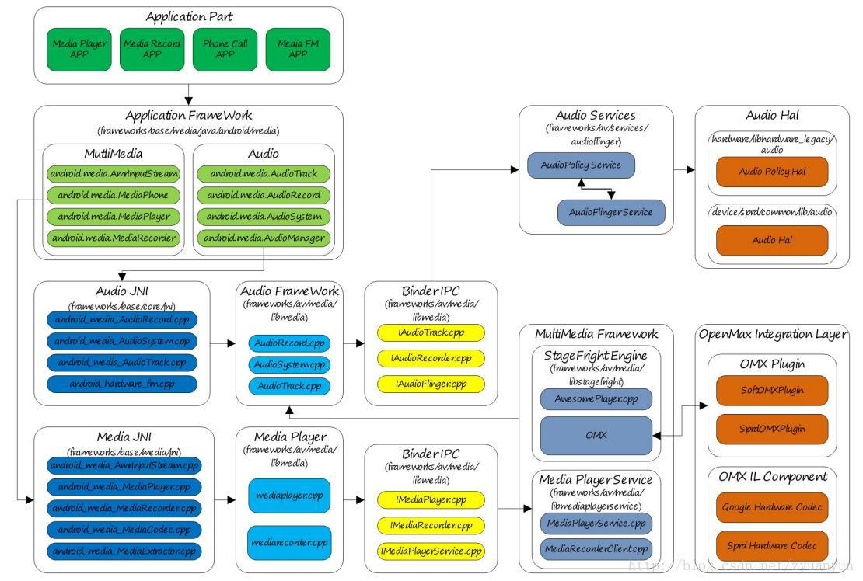

Android Audio on open-Q 820(APQ8096) INTRINSYC Platform:

ACDB:Audio calibration database
http://kernel-develop.blogspot.com/2012/06/acdb-audio-calibration-database-images.html
https://android.googlesource.com/platform/hardware/qcom/audio/+/refs/heads/jb-mr2-dev/hal/audio_hw.c Hal file path
ACPH:android_tools_leeco_msm8996/blob/master/mm-audio/audcal/legacy_intf/common/acph/inc/acph.h
* This header file contains all the definitions necessary for Audio Calibration
* Packet Handler to handle request buffer and operate ACDB
* This acph works only in ARM9

https://www.androidexplained.com/cyanogenmod-enable-root/
kingoroot apk downloaded for root access of msm board
You can use the code below to install application from command line
adb install KingoRoot.apk
adb install -r .apk reinstall or install updated app
adb install -s .apk install app to sd card
adb uninstall .apk uninstall app
mediainfo command is used to know the sound file information

Android build steps:
https://elinux.org/Android_Build_System
https://pandaboard.narkive.com/soHEgtS3/testing-audio-interface-from-command-line
https://android.googlesource.com/platform/build/+/master/Changes.md
Establishing build environment for android:
https://source.android.com/setup/build/initializing
ninja error in android build:
Try export USE_NINJA=false it will desable ninja
https://forum.khadas.com/t/building-with-ninja-failing/1960/25
https://forum.khadas.com/t/build-android-failed/646/20
https://groups.google.com/forum/#!topic/android-building/bNjUt5fSb2E use this for ninja error
export USE_NINJA=false
https://issuetracker.google.com/issues/37075225
https://github.com/sandymanu/device_hammerhead/issues/1
https://www.maketecheasier.com/common-adb-commands/
Compile one module in android:
source build/envsetup.sh
lunch msm8996-userdebug
go to file ptah(if it is having make file) exmple /android/external/tinyalsa and give command mm
After that getting like this(modified in tinyplay.c file)
out/host/linux-x86/obj32/STATIC_LIBRARIES/libtinyalsa_intermediates/libtinyalsa.a
After that push that libtinyalsa file using adb push.

Building only an individual program or module
If you use build/envsetup.sh, you can use some of the defined functions to build only a part of the tree. Use the 'mm' or 'mmm' commands to do this.
The 'mm' command makes stuff in the current directory (and sub-directories, I believe). With the 'mmm' command, you specify a directory or list of directories, and it builds those.
To install your changes, do 'make snod' from the top of tree. 'make snod' builds a new system image from current binaries
Creating Dynamic library:
https://stackoverflow.com/questions/14884126/build-so-file-from-c-file-using-gcc-command-line
1.gcc -c -fPIC hello.c -o hello.o
2.gcc hello.o -shared -o libhello.so
or
gcc -shared -o libhello.so -fPIC hello.c

coverting static library(.a) into dynamic library (.so):
https://stackoverflow.com/questions/655163/convert-a-static-library-to-a-shared-library
1.ar -x libtinyalsa.a
2.gcc -shared *.o -o libtinyalsa.so
How to take logs from android device?
https://stackoverflow.com/questions/2882253/how-do-i-get-the-logfile-from-an-android-device
https://developer.android.com/studio/debug/am-logcat
https://android.stackexchange.com/questions/14430/how-can-i-view-and-examine-the-android-log
pcm_write error:
https://ez.analog.com/linux-device-drivers/linux-software-drivers/f/q-a/115032/adau1761-alsa-problem
https://stackoverflow.com/questions/16185664/copying-executables-to-system-bin-in-android
https://stackoverflow.com/questions/16185664/copying-executables-to-system-bin-in-android
http://man7.org/linux/man-pages/man3/fopen.3.html
http://man7.org/linux/man-pages/man3/fread.3.html
https://linux.die.net/man/3/memset
https://www.geeksforgeeks.org/memset-c-example/
https://unix.stackexchange.com/questions/353125/understanding-what-channels-buffer-size-period-size-bindings-and-ipc
https://www.alsa-project.org/wiki/FramesPeriods frame period
https://stackoverflow.com/questions/29968096/get-android-os-version-of-device-connected-via-adb
https://tech.intrinsyc.com/projects/open-q-820-dev-kit/documents Intrinsyc website
https://stackoverflow.com/questions/21173628/what-is-boot-img-file-in-android
https://stackoverflow.com/questions/43500163/how-can-i-build-bootimage-without-going-through-all-makefiles
https://www.liquidweb.com/kb/using-rsync-to-transfer-and-synchronize-local-and-remote-systems/ rsync from server to host files
https://ez.analog.com/linux-device-drivers/linux-software-drivers/f/q-a/97628/sound-asoc-codec-dai-ssm2602-hifi-not-registered
https://lwn.net/Articles/761107/
https://patchwork.kernel.org/cover/10756015/
https://stackoverflow.com/questions/3707880/using-adb-logcat-with-a-real-phone-and-not-the-emulator
https://medium.com/@budhdisharma/android-log-analysis-176f9b9dafaf logcat analysis https://lore.kernel.org/lkml/20180912114633.GU4185@dell/T/ playback and record 9335 patch
https://www.alsa-project.org/pipermail/alsa-devel/2018-March/133141.html
https://android.googlesource.com/kernel/msm/+/android-msm-sturgeon-3.10-marshmallow-mr1-wear-release/sound/soc/msm/qdsp6v2/msm-pcm-routing-v2.c
https://forum.odroid.com/viewtopic.php?t=5996 HAL
https://www.systutorials.com/docs/linux/man/1-alsaucm/ ALSA use case manager
https://www.alsa-project.org/alsa-doc/alsa-lib/group__ucm.html
https://stackoverflow.com/questions/7964685/how-to-get-verbose-logging-in-logcat-for-a-specific-module enable verbose logs in android
https://www.slideshare.net/wiliwe/20110721-android-logging-system
http://ccppcoding.blogspot.com/2012/08/android-multimedia-interview-questions.html
https://blog.csdn.net/Ciellee/ Audio basics and framework basics
https://blog.csdn.net/
https://blog.csdn.net/Java_
https://blog.csdn.net/
https://blog.csdn.net/weixin_
https://blog.csdn.net/qq_
https://www.cnblogs.com/muhe221/category/670204.html Audio Material
https://www.tecmint.com/35-practical-examples-of-linux-find-command/ find commands
https://stackoverflow.com/questions/15557933/receive-audio-via-bluetooth-in-android bluetooth audio flow
https://source.android.com/devices/audio android audio
https://blog.csdn.net/iteye_19133/article/details/82404635 Audio Architecture overview
https://blog.csdn.net/jgw2008/article/details/52610102
https://blog.csdn.net/ch853199769/article/details/79916166 HAL compress-offload,low latency
https://blog.csdn.net/tjy1985/article/details/7398193 audio playback in framework
https://www.cnblogs.com/muhe221/articles/4462645.html HAL Architecture
https://www.cnblogs.com/muhe221/articles/4462320.html Audio HAL architecture
Audio HAL output stream device:
In Audio HAL, we usually see the following 4 output stream devices, which correspond to different playback scenarios:
primary_out : the main output stream device, used for ringtone sound output, corresponding to the audio stream identified by AUDIO_OUTPUT_FLAG_PRIMARY and a MixerThread playback thread instance
low_latency : low-latency output stream device, used for key delay, game background sound and other high-latency sound output, corresponding to the audio stream identified by AUDIO_OUTPUT_FLAG_FAST and a MixerThread playback thread instance
deep_buffer : music track output stream device, used for music and other low-delay sound output, corresponding to the audio stream identified by AUDIO_OUTPUT_FLAG_DEEP_BUFFER and a MixerThread playback thread instance
compress_offload : a hard-decompressed output stream device for data output that requires hardware decoding, corresponding to the identifier AUDIO_OUTPUT_FLAG_COMPRESS_OFFLOAD
Relationship between PlaybackThread and output stream device: PlaybackThread instance corresponds to output stream device one by one. For example, OffloadThread only outputs audio data to the compress_offload device, and MixerThread (with FastMixer) only outputs audio data to low_latency device.
The following figure briefly describes the correspondence between AudioTrack, PlaybackThread, and output stream devices:

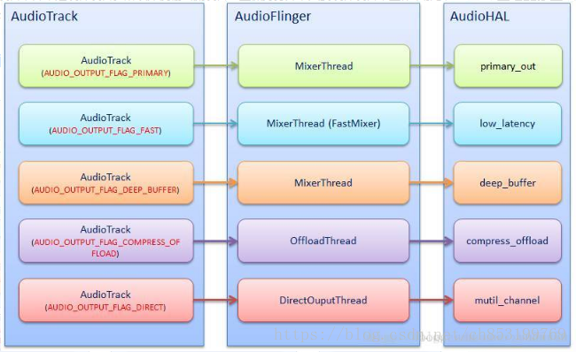
https://blog.csdn.net/weixin_30607659/article/details/99778428 Android audio code analysis
Various sound control strategies are mainly implemented in Audio Policy Manager.
Which will make necessary changes to the volume of various streams according to the stream type and current status.
To achieve the following priority effects:
Priority Strategy Type Stream Type
4 STRATEGY_PHONE VOICE_CALL
BLUETOOTH_SCO
3 STRATEGY_SONIFICATION RING
NOTIFICATION
ALARM
ENFORCED_AUDIBLE
2 STRATEGY_MEDIA SYSTEM
TTS
MUSIC
1 STRATEGY_DTMF DTMF

https://blog.csdn.net/flyingqr/article/details/8808695 Android audio architecture analysis
AudioPolicyService Introduction
AudioPolicyService is one of the two major services in the android audio system, and the other is AudioFlinger.

Main functions:

1. Detect and set the connection status of input and output devices

2. Choice of switching strategy for audio system

3. Setting of volume and audio system parameters

4. Setting of sound effects

AudioPolicyService related code
frameworks / av / services / audioflinger / AudioPolicyService.cpp
hardware / libhardware_legacy / audio / AudioPolicyManagerBase.cpp

hardware / libhardware_legacy / audio / audio_policy_hal.cpp

hardware / libhardware_legacy / audio / AudioPolicyCompatClient.cpp
AudioPolicyManager connects to AudioPolicyService
AudioPolicyManager:

It is not directly connected to AudioPolicyService, but connected through AudioPolicyCompatClient

https://blog.csdn.net/ffmpeg4976/article/details/50568637 OMX player and stagefrightplayer
https://blog.csdn.net/Ciellee/article/details/88765469 Android framework overview important
AudioPolicyService: Formulator of audio policy, responsible for audio device switching strategy selection, volume adjustment strategy, etc.
AudioFlinger: Implementer of audio policy, responsible for management of input and output stream devices and processing and transmission of audio stream data.
Audio HAL: Audio hardware abstraction layer Responsible for interaction with audio hardware devices, directly called by AudioFlinger.

https://blog.csdn.net/Ch97CKd/article/details/78641457 framework explanation, important for audio playback flow
https://download.csdn.net/download/weixin_38669628/11040515 Android all material from audioflinger to tinyalsa
https://blog.csdn.net/WAN8180192/article/details/50705893 audioflinger
https://blog.csdn.net/Joyce0205/article/details/84971350
Strongly related to Audio is MultiMedia. MultiMedia is responsible for the encoding and decoding of audio and video. MultiMedia outputs the decoded data through AudioTrack, and the recorded data collected by AudioRecord is encoded by MultiMedia.
You can use MediaPlayer and AudioTrack to play sounds. Both of them provide java API for developers. Although both can play sounds, there is a big difference between the two. The biggest difference is that MediaPlayer can play sound files in multiple formats, such as MP3, AAC, WAV, OGG, MIDI, etc. MediaPlayer will create the corresponding audio decoder in the framework layer. AudioTrack can only play the decoded PCM stream. If it is a file, it only supports wav format audio files, because most of the wav format audio files are PCM streams. AudioTrack does not create a decoder, so it can only play wav files that do not need to be decoded. Of course, there is still a close relationship between the two. MediaPlayer still creates an AudioTrack in the framework layer, passes the decoded PCM data stream to AudioTrack, and AudioTrack then passes it to AudioFlinger for mixing, and then passes it to the hardware for playback, so it is MediaPlayer. Contains AudioTrack

After the AudioTrack instance is constructed, the application can then write audio data. As described earlier: AudioTrack and AudioFlinger are producer-consumer relationships:
- AudioTrack: AudioTrack finds a free space in the FIFO, writes the user's incoming audio data to this free space, and then updates the write position (for AudioFinger, it means more readable data on the FIFO); If the amount of data passed in by the user is larger than the available space, the data passed in by the user must be split and written to the FIFO multiple times (AudioTrack and AudioFlinger are different processes, and AudioFlinger is also constantly reading the data. So the FIFO free space is constantly changing)
- AudioFlinger: AudioFlinger finds a readable data block in the FIFO, copies the readable data to the destination buffer, and then updates the read position (for AudioTrack, it means that there is more free space on the FIFO); if it is on the FIFO The amount of readable data is smaller than expected, so it takes multiple reads to accumulate the expected amount of data (AudioTrack and AudioFlinger are different processes, AudioTrack is also constantly writing data, so the FIFO is readable The amount of data is constantly changing)

The process of establishing connection:
- Framework or Java layer through JNI, new AudioTrack ();
- According to parameters such as StreamType, through a series of calls to getOutput ();
- If necessary, AudioFlinger opens different hardware devices according to StreamType;
- AudioFlinger creates a mixing thread for the output device: MixerThread (), and returns the id of the thread to AudioTrack as the return value of getOutput ();
- AudioTrack calls createTrack () of AudioFlinger through the binder mechanism;
- AudioFlinger registers the AudioTrack to MixerThread;
- AudioFlinger creates a TrackHandle for control, and uses the IAudioTrack interface as the return value of createTrack ();
- AudioTrack gets the FIFO (audiotrackcblk_t) created in AudioFlinger through the IAudioTrack interface;
- AudioTrack creates its own monitoring thread: AudioTrackThread;
Since then, AudioTrack has established all connections with AudioFlinger. Next, AudioTrack can:
- Control the state of the track through the IAudioTrack interface, such as start, stop, pause, etc .;
- Realize continuous audio playback by writing to FIFO;
- The monitoring thread monitors the occurrence of events and interacts with the user program through the audioCallback callback function;

https://blog.csdn.net/tjy1985/article/details/7398193 Audio/video play flow
https://blog.csdn.net/u012489236/article/details/98079176 Registation of ALSA
https://blog.csdn.net/DroidPhone/article/details/7165482 ALSA ASoC
Sample : sample length, the most basic unit of audio data, common 8-bit and 16-bit;
Channel : number of channels, divided into mono and stereo;
Frame : a frame, form a complete sound unit, a so-called sampling sound unit refers to a sample Frame = Sample * channel;
Rate : also known as sample rate, that is, the number of samples per second, for the frame;
Period Size : period, the number of frames of audio data processed by each hardware interrupt, for data read and write of audio equipment, as a unit;
Size Buffer : data buffer size, referred to herein as runtime of the buffer size, rather than the structure of FIG snd_pcm_hardwaredefined buffer_bytes_max; general buffer_size = period_size * period_count, period_count equivalent to a processed data buffer required hardware interrupts.
https://blog.csdn.net/zyuanyun/article/details/59180272#t6 frame,period and pcm device creation
https://blog.csdn.net/u010164190/article/details/72902539
https://blog.csdn.net/ShareUs/article/details/85266982
https://www.cnblogs.com/muhe221/articles/4433052.html https://ez.analog.com/linux-device-drivers/linux-software-drivers/f/q-a/97628/sound-asoc-codec-dai-ssm2602-hifi-not-registered codec dai hifi not registered
Qualcomm links:
https://developer.qualcomm.com/forum/qdn-forums/software/hexagon-dsp-sdk/hardware-support/33914 for Hexagon dsp architecture
https://www.anandtech.com/show/9552/qualcomm-details-hexagon-680-dsp-in-snapdragon-820-accelerated-imaging
https://developer.qualcomm.com/forum/qdn-forums/software/hexagon-dsp-sdk/hardware-support/52652
https://developer.qualcomm.com/forum/qdn-forums/software/hexagon-dsp-sdk/audio-capiappi/29799
https://developer.qualcomm.com/forum/qdn-forums/mobile-technologies/multimedia-optimization-hexagon-sdk/audio-capiappi/27094
RIFF wave header explanation:
http://www.topherlee.com/software/pcm-tut-wavformat.html
http://soundfile.sapp.org/doc/WaveFormat/

Error numbers in Linux system:
When system requests fail, error code are returned. To understand the nature of the error these codes need to be interpreted. They are recorded in:-
/usr/include/asm/errno.h
https://www-numi.fnal.gov/offline_software/srt_public_context/WebDocs/Errors/unix_system_errors.html

Android version:
To know android version : adb shell getprop | grep version https://blog.csdn.net/u013928208/article/details/81628596 AudiFlinger for android 8.0
https://blog.csdn.net/u013928208/article/details/81667162 Audio HAL for 8.0
https://blog.csdn.net/ch853199769/article/details/81781624 AudioFlinger review
https://blog.csdn.net/kangear/article/details/38139669 Tinyalsa
https://blog.csdn.net/gbmaotai/article/details/82253745 Android AudioFramework

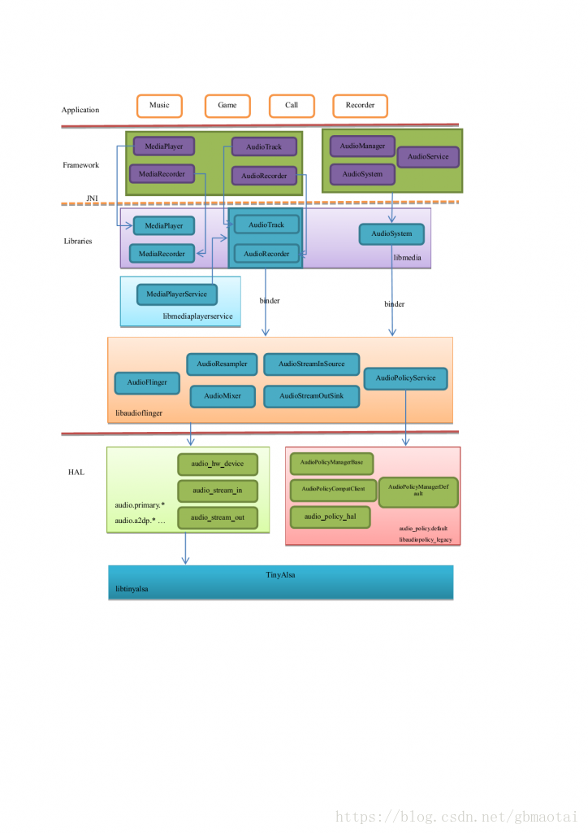
https://groups.google.com/forum/#!topic/android-platform/TauUHyKEKWU Tinyplay

The process of establishing a connection:
- Framework or Java layer through JNI, new AudioTrack ();
- According to parameters such as StreamType, through a series of calls to getOutput ();
- If necessary, AudioFlinger opens different hardware devices according to StreamType;
- AudioFlinger creates a mixing thread for the output device: MixerThread (), and returns the id of the thread to AudioTrack as the return value of getOutput ();
- AudioTrack calls createTrack () of AudioFlinger through the binder mechanism;
- AudioFlinger registers the AudioTrack to MixerThread;
- AudioFlinger creates a TrackHandle for control, and uses the IAudioTrack interface as the return value of createTrack ();
- AudioTrack gets the FIFO (audiotrackcblk_t) created in AudioFlinger through the IAudioTrack interface;
- AudioTrack creates its own monitoring thread: AudioTrackThread;
Since then, AudioTrack has established all connections with AudioFlinger. Next, AudioTrack can:
- Control the state of the track through the IAudioTrack interface, such as start, stop, pause, etc .;
- Realize continuous audio playback by writing to FIFO;
- The monitoring thread monitors the occurrence of events and interacts with the user program through the audioCallback callback function;

https://stackoverflow.com/questions/15649580/using-in-c scope resolution operator in c++

Android Framework:

https://blog.csdn.net/Ciellee/article/details/88765469 Android audio framework overview
https://blog.csdn.net/xuesen_lin/article/details/8805068?depth_1-utm_source=distribute.pc_relevant.none-task&utm_source=distribute.pc_relevant.none-task Android audio system1
https://blog.csdn.net/xuesen_lin/article/details/8805168?depth_1-utm_source=distribute.pc_relevant.none-task&utm_source=distribute.pc_relevant.none-task
audio track for android system
https://blog.csdn.net/qq_38261174/article/details/82871542?depth_1-utm_source=distribute.pc_relevant.none-task&utm_source=distribute.pc_relevant.none-task play audio pcm with audio track
https://blog.csdn.net/ch853199769/article/details/79916166 Android audio playback mode
https://blog.csdn.net/Ciellee/article/details/88777223 Audioflinger Android audio system2
https://blog.csdn.net/xuesen_lin/article/details/8805091 3
https://blog.csdn.net/xuesen_lin/article/details/8805096 4
https://blog.csdn.net/ch853199769/article/details/81781624 Android audiofllinger review
https://blog.csdn.net/ch853199769/article/details/81635252 Review of audiotrack for android
https://blog.csdn.net/marshal_zsx/article/details/81060100
https://blog.csdn.net/fuzhen1986/article/details/43192903
https://blog.csdn.net/marshal_zsx/article/details/81076253
https://blog.csdn.net/Ch97CKd/article/details/78641457 Audio Framework,flinger,mixer
https://blog.csdn.net/xuesen_lin/article/details/8805168 Audio Track Application for android
https://blog.csdn.net/xuesen_lin/article/details/8805182 Audio policy service routing implementation
https://blog.csdn.net/shell812/article/details/73467010 Alsa audio system Architecture
below topics check in this page:
Analysis of android audio driver
analysis of android Audio driver
Audio driver architecture under ALSA
https://blog.csdn.net/orz415678659/article/details/8866071?depth_1
Audio code structure
utm_source=distribute.pc_relevant.none-task&utm_source=distribute.pc_relevant.none-task
utm_source=distribute.pc_relevant.none-task&utm_source=distribute.pc_relevant.none-task
https://blog.csdn.net/ShareUs/article/details/85266982 Android AudioTrack play (decode) audio
https://blog.csdn.net/hanbo622/article/details/44514371 i2s,bit clocl,MCLK

Interrupts:
https://www.thegeekstuff.com/2014/01/linux-interrupts/

cat /proc/interupts
cat /proc/irq
watch -n1 "cat /proc/interrupts" to see running interupts on your system

https://blog.csdn.net/u010164190/article/details/94437351 android audio architecture important

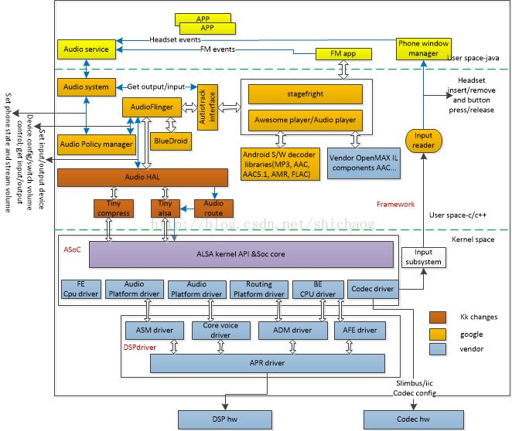

https://blog.csdn.net/Vincentywj/article/details/77676588 AsoC pcm open
https://blog.csdn.net/Vincentywj/article/details/77849442 AsoC pcm write
https://blog.csdn.net/Vincentywj/article/details/77839806 AsoC pcm prepare
https://download.csdn.net/download/ni_lo/4199717?depth_1-utm_source=distribute.pc_relevant.none-task&utm_source=distribute.pc_relevant.none-task Android_ audio device driver full analysis
https://groups.google.com/forum/#!topic/android-platform/WtEN-E3EvQI shared memory between audioclient and audioflinger
Qualcomm Audio: Important

https://blog.csdn.net/whshiyun/article/details/80889838 AsoC audio path for msm8996 important
https://blog.csdn.net/zyuanyun/article/details/59170418 Audio kernel driver flow in ALSA
https://blog.csdn.net/q1075355798/article/details/80657365 Android learning one
https://blog.csdn.net/zyuanyun/article/details/59180272 Soundcard creation process
https://blog.csdn.net/droidphone/category_1118446.html
https://blog.csdn.net/DroidPhone/article/details/7283833 Codec in AsoC Architecture
http://kernel-develop.blogspot.com/2012/06/acdb-audio-calibration-database-images.html ACDB file changes for audio playback and capture
https://blog.csdn.net/shell812/article/details/73467010 ALSA android audio architecture
https://blog.csdn.net/u013531497/article/details/45249533 Audio code structure
https://blog.csdn.net/azloong/article/details/79383323 Qualcomm Audio HAL audio path settings
https://blog.csdn.net/zmjames2000/article/details/88015436 HAL
https://blog.csdn.net/weixin_42082222/article/details/81189637 Qualcomm audio learningone
https://blog.csdn.net/weixin_42082222/article/details/81183859 Qcat tool
https://blog.csdn.net/weixin_34321977/article/details/86129313 qcat record
https://download.csdn.net/download/feijun2015/11261352 Qualcomm audio debugging
https://blog.csdn.net/u012899335/article/details/82594381 qcom audio debugging notes
https://blog.csdn.net/u012899335/article/details/82312766 headset detection
https://download.csdn.net/download/menghuanchizi/5246420 Qualcomm Platform-Driven Development document
https://www.bbsmax.com/A/nAJvb9AaJr/ qcom machine driver
https://blog.csdn.net/weixin_30700977/article/details/99663915?depth_1-utm_source=distribute.pc_relevant.none-task&utm_source=distribute.pc_relevant.none-task machine driver in qcom
https://stackoverflow.com/questions/39746221/what-is-required-to-make-android-use-a-new-audio-hal required to make new audio HAL
https://blog.csdn.net/weixin_43013761/article/details/89711491?depth_1-utm_source=distribute.pc_relevant.none-task&utm_source=distribute.pc_relevant.none-task HAL source code analysis
Now let ’s review. Suppose there is an android phone with a speaker on it. When we listen to music, the sound will be played in the speaker. When the headset is plugged in, the sound will be played from the headset. Then this whole What does the process involve?
1. Play from headphones first, which is determined by AudioPolicyService
2. If there are multiple apps to play sound, AudioFlinger is responsible for mixing the sounds of multiple apps, of course, there are many other functions besides this.
3. Final to operate the hardware, there are several sound cards, you can dynamically swap (USB sound card, Bluetooth card), for each card consists of a module (so files) to manipulate him, that HAL
4. In order to simplify the operation of the sound card There is a tinyalsa library. Only pcm_open, pcm_wirte, pcm_read can be used to play the recording.
5.pcm_open, pcm_wirte, pcm_read access the driver through standard open, wirte, read, and then control the driver to access the hardware.
Let's first look at the operation flow of HAL:
1. Determine the name of the so file from the /system/etc/audio_policy.conf configuration file.
2. Load the so file
3. The open function construct in the HAL file and return an audio_hw_device_t structure, which contains adev_open_output_stream, adev_open_input_stream.
AudioFlinger then uses audio_hw_device_t to construct an AudioHwDevice object, and each sound card corresponds to an audio_hw_device_t and AudioHwDevice. Put into the array mAudioHwDeviceS.
4. Call adev_open_output_stream in the audio_hw_device_t structure in the hal file to build an audio_stream_out structure and return it to AudioFlinger. AudioFlinger uses it to create a MixerThread thread according to him.

According to the figure, adev_open_output_stream will eventually be called.

5.write to the sound card,

Headset detection using adb shell:

getevent -l
127|msm8996:/sdcard/Music # getevent -l
add device 1: /dev/input/event7
name: "msm8996-tasha-db-snd-card Button Jack"
add device 2: /dev/input/event6
name: "msm8996-tasha-db-snd-card Headset Jack"
could not get driver version for /dev/input/mouse1, Not a typewriter
add device 3: /dev/input/event4
name: "hbtp_vm"
add device 4: /dev/input/event3
name: "goodix-ts"
could not get driver version for /dev/input/mouse0, Not a typewriter
add device 5: /dev/input/event2
name: "qbt1000_key_input"
add device 6: /dev/input/event1
name: "HDMI CEC User or Deck Control"
add device 7: /dev/input/event0
name: "qpnp_pon"
could not get driver version for /dev/input/mice, Not a typewriter
add device 8: /dev/input/event5
name: "gpio-keys"
130|msm8996:/sdcard/Music # getevent -l /dev/input/event6
EV_SW SW_HEADPHONE_INSERT 00000000
EV_SW SW_MICROPHONE_INSERT 00000000
EV_SW SW_JACK_PHYSICAL_INS 00000000
EV_SYN SYN_REPORT 00000000
EV_SW SW_HEADPHONE_INSERT 00000001
EV_SW SW_MICROPHONE_INSERT 00000001
EV_SW SW_JACK_PHYSICAL_INS 00000001
EV_SYN SYN_REPORT 00000000

recover from fastboot mode:
file:///home/ajaykumar/Downloads/Open-Q%20820%20release%20notes%20for%20Linux%20BSP%20v3.4.pdf
https://androidmtk.com/use-qualcomm-sw-downloader
https://www.96boards.org/documentation/consumer/dragonboard/dragonboard820c/installation/board-recovery.md.html
https://mirrors.edge.kernel.org/caf_patches/quic/la/ Audio patches
https://tektab.com/2015/10/31/android-bootloaderfastboot-mode-and-recovery-mode-explained/ bootloader explanation
https://opensourceforu.com/2014/10/an-introduction-to-device-drivers-in-the-linux-kernel/ Device drivers notes,character driver
https://github.com/Kunena/Kunena-Forum/wiki/Create-a-new-branch-with-git-and-manage-branches git commands
https://www.tecmint.com/load-and-unload-kernel-modules-in-linux/ interview questions
https://www.oreilly.com/library/view/linux-device-drivers/0596005903/ch02.html building module
https://www.thegeekstuff.com/2013/07/write-linux-kernel-module/ Wrting linux kernel module
http://tldp.org/LDP/lkmpg/2.6/html/lkmpg.html#AEN128 linux kernel modular programming

